THE NATIONAL AGRICULTURAL MARKETING AND DEVELOPMENT CORPORATION (NAMDEVCO)



GUIDE TO EXPORTING
FRESH PRODUCE

“Taking Trinidad and Tobago Foods to the World”

==================================================

NAMDEVCO Email: namdevco@rave-tt.net
S.S. Erin Road Tel: 1-868-647-3218/7576
Debe Fax: 1-868-647-6087
Trinidad & Tobago Website: www.namdevco.com

TABLE OF CONTENTS

Page
1.0 Introduction ………………………………………………………… 2
2.0 Regulations …………………………………………………………. 2
3.0 Know Your Market …………………………………………………. 2
Market Research ……………………………………………………. 2
4.0 Selection of Importer ……………………………………………….. 3
5.0 Export Pricing ………………………………………………………. 4
6.0 Making a Shipment …………………………………………………. 5
7.0 Terms of Payment …………………………………………………… 6
8.0 Documentation ……………………………………………………… 6
9.0 International Trade Terms ………………………………………….. 7
10.0 Other Relevant Terms ……………………………………………… 8
11.0 Support Services for Exporters ……………………………………. 9
12.0 Freight Service Providers ………………………………………….. 11
13.0 Appendix I - List of items shipped to each country………………….. 13
14.0 Appendix II - Export Forms …………………………………………. 14
A. Customs Form C82 ……………………………………………… 14
B. CARICOM Invoice ……………………………………………… 16
C. Airway Bill ……………………………………………………… 17
D. Bill of Lading ……………………………………………………. 18
E. Phytosanitary Certificate ………………………………………… 19
F. EUR 1 Form ……………………………………………………… 20

1.0 INTRODUCTION

The advent of globalization and trade liberalization has resulted in increased growth in the trade in agricultural products.

Trinidad and Tobago like many other countries has over the years been exporting its fresh produce to the region as well as to the U.S.A, Canada and the European Union countries mainly to the United Kingdom.

This country exports a range of products to these various markets (see Appendix I for list of items shipped to each country).

In order to successfully export produce, exporters must follow procedures and guidelines involve Customs, health and other regulations.

This Guide to the Export of Fresh Produce seeks to address all the procedures involved and make it easy for the exporter to do business.

2.0 REGULATIONS

An individual, partnership or registered company can be an exporter. There are no restrictions on who or what type of business can export from the country but the products must comply with existing export regulations.

Commercial shipments leaving the country must be declared with the Custom and Excise Department. This declaration to Customs must be made by a licensed Customs broker appointed by the exporter.

Fresh produce exports must comply with Phytosanitary regulations. To do so the shipment must be presented to the Plant Quarantine Office at the air or sea port or in some cases at the NAMDEVCO Packinghouse for inspection. Once the shipment is passed fit for export a Phytosanitary Certificate is issued. This Certificate must accompany the other shipping documents sent to the importer.

3.0 KNOW YOUR MARKET

Market Research

You must have known what your target market wants. In order to get this information, market research must be undertaken. This research can be done by you or someone employed by you. The objective of research is to provide the required information on which to base your export strategy.

There are two types primary and secondary.

Secondary Research
This is the process of gathering information within Trinidad and Tobago.

The possible sources of secondary information are

NAMDEVCO which is the agency mandated to facilitate market development for the country’s agri food products will be the main source of primary information.

Other sources are:
- The Internet,
- Embassies/High Commissions
- Business Organisation such as Chambers of Commerce

Primary Research

This is the process of gathering information in the target market. It involves visiting the target market to get information by speaking to importers/distributors and or wholesalers as well as visiting Trade Fairs/Exhibitions

It is advisable to gather as much information from secondary research before undertaking research in the market place.

Primary research would seek to get information on;

- Economic overview of target market
- Import regulations
- Duties and taxes
- Distribution network
- Current suppliers
- Prices
- Listing of potential buyers
- Trading terms
- Packaging and presentation

These are just some of the main factors to consider when seeking to venture into the export market.

4.0 SELECTION OF IMPORTER

This is a very important process in exporting. You want to ensure that the person/company you are dealing with is reliable, and has a good history in the timeliness of remitting payments.

There are references sources that give background details on importers. For example for the U.S and Canadian markets there is the Red Book Credit Services which provides this kind of information. NAMDEVCO has a copy of the Red Book for use by current and potential exporters.

In addition the EXIMBANK does background checks on importers on behalf of exporters using their export financing facility.

5.0 EXPORT PRICING

Once you have established market prospects as well as potential buyers, the next step is to calculate the price to be quoted to the importer. The price can either be FOB, C&F or CIF.

The following elements are included in an export pricing model.

EXPORT PRICING MODEL

PURCHASE PRICE OF PRODUCE

TRANSPORT COSTS TO PACKINGHOUSE

PROCESSING AND PACKAGING COSTS AT PACKINGHOUSE

TRANSPORT COSTS TO AIR/SEA PORT

CUSTOMS BROKER FEES

EXPORTERS MARK UP

= FREE ON BOARD PRICE (FOB PRICE)

AIR OR SEA FREIGHT CHARGES

= COST AND FREIGHT PRICE TO IMPORTER (C&F PRICE)

INSURANCE

= COST INSURANCE AND FREIGHT PRICE (CIF PRICE)

6.0 MAKING A SHIPMENT

Once interest has been generated by the importer and he is satisfied with the price and terms such as method of payment, time of payment as well as conditions relating to spoilage etc are agreed, the exporter now swings into full gear to have the shipment ready.

Depending on the type of item to be exported and the proximity to the market, the export can either ship by air or sea. A highly perishable product like Hot Peppers is sent by air while bulk items like Pumpkins is sent by sea.

The choice between air or ocean freight depends on:
- cost
- destination
- storage life of produce
- frequency of shipping
- transit time
- risks involved
- size and weight of shipment

The exporter has to make the following arrangements in order to make a shipment

- Source the produce from the farmer(s)
- Arrange transport to deliver to packinghouse for processing and packaging.
- If using NAMDEVCO or other packinghouse arrange time of delivery for processing
- Book the required cargo space with airline or shipping company as required
- Provide details of shipment to Customs Broker to have export documentation prepared and processed

- If shipping to the U.S.A ensure you are registered with the US Food and Drugs Administration(FDA) re the BioTerrorism Act (NAMDEVCO can assist with this).Upon registration each exporter will be issued a Personal Identification Number(PIN).This has to be used for advising the FDA(Prior Notice) on details of every shipment made. Prior Notice must be sent to the FDA and confirmed by them no more than 5 days before arrival of a shipment in the U.S and no less than 4 hours for shipment by air and 8 hours for shipment by sea.

- Arrange with Plant Quarantine Office at air or sea port to have produce inspected for Phytosanitary Certificate to be issued. Users of the NAMDEVCO Packinghouse can arrange for the Plant Quarantine Officer to do inspection at this facility.

- Arrange appropriate transport of packed produce to air or sea port by the required time

7.0 TERMS OF PAYMENT

There are a number of ways that payment can be made. The common ones for agri food products are:

- Advance Payment

- the exporter is paid before the shipment of goods. This is the ideal form of payment for the exporter. This may not always be possible however.

- Open Account

- the exporter is paid after the goods have been received by the importer and
found to be acceptable.

8.0 DOCUMENTATION (Copies of all these documents are shown in the Appendix I)

- C 82 Form

Customs Declaration Form, also called the 'Shipping Bill'
- Used for Imports and Exports of Goods
- Must be filled out completely and accurately by a licensed customs broker
- Used for compiling statistics of a country’s import and export.

- CARICOM Invoice

- Represents a legal document between buyer and seller
- Must be filled out completely and accurately by a licensed customs broker
- Used for imports and exports
- Gives a detailed description of the shipment, e.g. number and weight of each package
- This document must be signed by the exporter or his representation.

- Airway Bill (Air Freight)

Prepared by the airline
- Made up of three (3) original copies. One each for the exporter, importer and the airline
- A receipt from the airline acknowledging it has received the consignment from the exporter
- Internationally standardized document
- Gives the exporter right of disposal
- Allows the importer/ receiver to receive the goods.

- Bill of Lading (Sea Freight)

- Prepared by the shipping company
- Made up of three (3) original copies. One each for the exporter, importer and the shipper
- Completed by the exporter or his freight forwarder
- Two (2) types –
- CARICOM – when shipping via the CARICOM Jetty
- International – each shipping line has its own format

- A receipt from the shipper acknowledging that it has received the consignment from the exporter
- A document of title giving ownership of the goods

An exporter may wish to use the services of a freight forwarding agent to simplify the documentation process. The freight forwarder will handle all the necessary documents for a fee.

- Phytosanitary Certificate

Issued by the Plant Quarantine Section

Free of Charge
- Confirms produce is treated and/or free from pest and disease
- Also states place of origin

- EUR1 Form
This is a Certificate of Origin and is required for trade between African, Caribbean and Pacific (ACP) countries and the European Union.

- Duty free form for entry into the European Union, including dependencies in the Caribbean
- Also known as a movement certificate
- Used for trace ability of shipment
- Certified by Customs

9.0 INTERNATIONAL TRADE TERMS

International trade has specific trade terms which an exporter must be familiar with.
Some of the terms that would apply to exporters of agric food products are listed below.

- FOB (Free on Board) – this term indicates the seller is responsible for all costs up to the point of delivery at the air or sea port. In such a situation the importer is responsible for the freight and other charges in order to get the goods into his warehouse.
- C & F (Cost and Freight) – If the terms between the exporter and importer are C&F the exporter pays all costs up to the point of arrival at the designated air or sea port in the importing country.
- CIF (Cost, Insurance and Freight) – The seller is responsible for all costs including insurance up to the point of arrival at air or sea port in the importing country.

FOB and C&F terms are the more commonly used in the export of fresh produce.

Based on the agreement between the exporter and importer, the quotation by the former would reflect which of the above term is to be used.

10.0 OTHER RELEVANT TERMS

Airway Bill
This is a contract to carry goods by air. This document is provided by the airline on the day of the shipment and includes details of buyer, seller, items exported and weight. The Airway Bill is sent together with all other relevant documents to the importer to enable clearance of the goods upon arrival.

Bill of Lading
This is a contract document which is used for products exported by sea. It is provided by the sea freight company. It contains the same information as the Airway Bill.

Consignee
The person to whom the shipment is sent, the importer

Consignor
The person who sends the shipment, the exporter

Container Vessel
This is a vessel that only carries containerized cargo. Containers are 20 or 40 feet, some are refrigerated.

Pumpkins are exported in 40 feet refrigerated containers.

Freight Forwarder
This is a company responsible for arranging freight with air or sea lines.

Some freight forwarders handle both air and sea while others specialize in either one. NAMDEVCO can assist with a listing of freight forwarders or it can be obtained from the Yellow Pages in the Telephone Directory

Freight Rate
The rate charged for transporting cargo. Rates vary depending on destination and volume shipped. Freight forwarders and or cargo companies will provide rates.

11.0 SUPPORT SERVICES FOR EXPORTERS

NAMDEVCO
The National Agricultural Marketing and Development Corporation (NAMDEVCO) is a State Agency mandated to promote marketing services and stimulate business investment in the agro-industrial sector.

We can assist with:
- Identification of buyers
- Provision of market price information
- Market research information
- Listing of producers
- Packinghouse services
- Market promotion

Contact details are:

The National Agricultural Marketing and Development Corporation (NAMDEVCO)
S.S Erin Road
Debe

Telephone - 647 – 3218/3467
Fax - 647 – 6087
Email: namdevco@tstt.net.tt
Website: www.namdevco.com

Packinghouse, Piarco
Tel- 669 – 7092
Fax- 669 – 7091

PLANT QUARANTINE DIVISION
This Division of the Ministry of Agriculture, Land and Marine Resources is responsible for the inspection and certification of all fresh leaving the country.

Contact details are:

Piarco International Airport Tel 669-4860
Port of Spain Wharf Tel 625-3266
Point Lisas Port Tel 636-0883

EXIMBANK OF TRINIDAD & TOBAGO

This organization provides financing and insurance packages for exporters.

The EXIMBANK has an Agricultural Policy catering to the needs of exporters of agri food products. This Policy is focused on promoting and supporting the export of locally produced agricultural products (fresh and processed). The policy protects an exporter of agricultural products from failure of its overseas customer/buyer to make agreed payments because of unforeseen commercial credit or political risks.

Contact details are:

EXIMBANK
Exim House
Marketing and Business Development
30 Queen’s Park West
Port of Spain

Tel 628- 2762/1382
Fax 628-622-3545
Email: eximbank@wow.net
Website: www.eximbanktt.com

AGRICULTURAL DEVELOPMENT BANK OF TRINIDAD & TOBAGO (ADB)

The ADB provides financing for agro enterprises; both fresh and processed food producers.

Under the GroSafe Loan package, the ADB provides two facilities. One is for producers in the Farm Certification and Monitoring Programme administered by NAMDEVCO, the other is for marketers who buy produce from these Certified farms.

For further details on how to access funding, contact the ADB at their Head Office or any of their Branch Offices.

Contact details for ADB Head Office are:

87 Henry Street
Port of Spain

Tel 623-6261/5
Fax 624-3087
Email adbpos@adbtt.com

12.0 FREIGHT SERVICE PROVIDERS

Air Freight

BWIA International
Cargo Division
Piarco International Airport
Piarco

Tel: 1-868-669-3000 ext 2668, 2663, 2671, 2443
Fax: 1-868-669-1973
Email: bweecargo@bwee.com

Amerijet Caribbean Express Limited
Cargo Department
South Side
Piarco International Airport
Piarco

Tel: 1-868-669-3221/0004/0007
Fax: 1-868-669-2003
Email: ace.pos@amerijet.com

American Airlines
Cargo
General Aviation Services Limited
Piarco International Airport
Piarco

Tel: 1-868-669-2630/2635
Fax: 1-868-669-0267
Email: cargo@gas.co.tt

Air Canada
Cargo
c/o Piarco Air Services
Cargo Complex
Caroni North Bank Road
Piarco
Tel: 1-868-669-4076/5285
Fax: 1-868-669-5194
Email: cargo@pasl.co.tt

Laparkan Shipping
Cargo Complex
Piarco International Airport
Piarco

Tel: 1-868-669-0287/7427
Fax: 1-868-669-0283
Email: fyzallpk@carib-link.net

Sea Freight

Tropical Shipping
Lot 18 Trincity Business Park
Golden Grove Road
Piarco

Tel: 1-868-692-5400/5402
Fax: 1-868-692-5442
Email: ebelcon@tropical.com or rmilford@tropical.com

Seaboard Marine Trinidad Limited
Port of Spain Main Office
Atlantic Avenue
P.O. Box 5225

Tel: 1-868-679-6370/1570
Fax: 1-868-679-6267
Email: info@seaboardtrinidad.com

Maersk Trinidad Ltd
Fitt House
Fitt Street
Woodbrook
Port of Spain
Tel 627-5746, 624-9349
Fax 627-8023

This list is not exhaustive nor does it indicate a recommendation of the companies listed

13.0 LIST OF ITEMS SHIPPED TO EACH COUNTRY – Appendix I

COUNTRIES | LIST OF ITEMS SHIPPED
Barbados | Cabbage, Okra, Tomato, Sweet Pepper, Watermelon,  Squash, Pumpkin, Pineapple, Cucumber, Cauliflower, Christophene, Citrus, Egg plant, Papaya
St. Lucia | Peas and beans, Melons, Cucumber, Pumpkin, Tomato, Peppers
United States | Mainly Hot Peppers and Pumpkin
Canada | Pumpkins, Egg plant, Hot Peppers, Sweet Potatoes,  Mangoes

- EXPORT FORMS – Appendix II

A. CUSTOMS FORM C82 (Front)

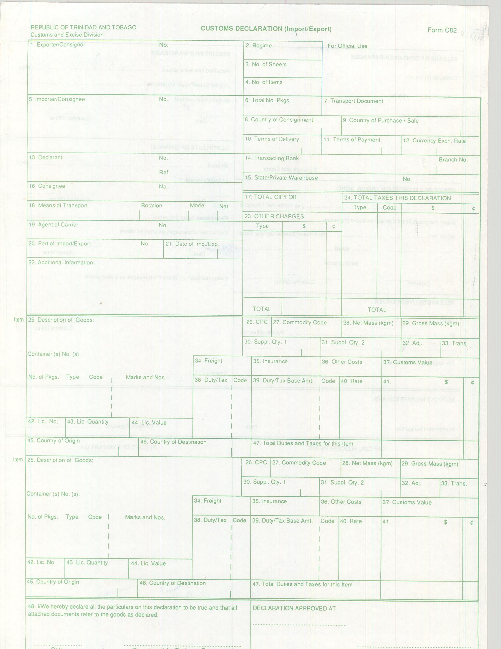

A. (Cont’d): CUSTOMS FORM C82 (Back)

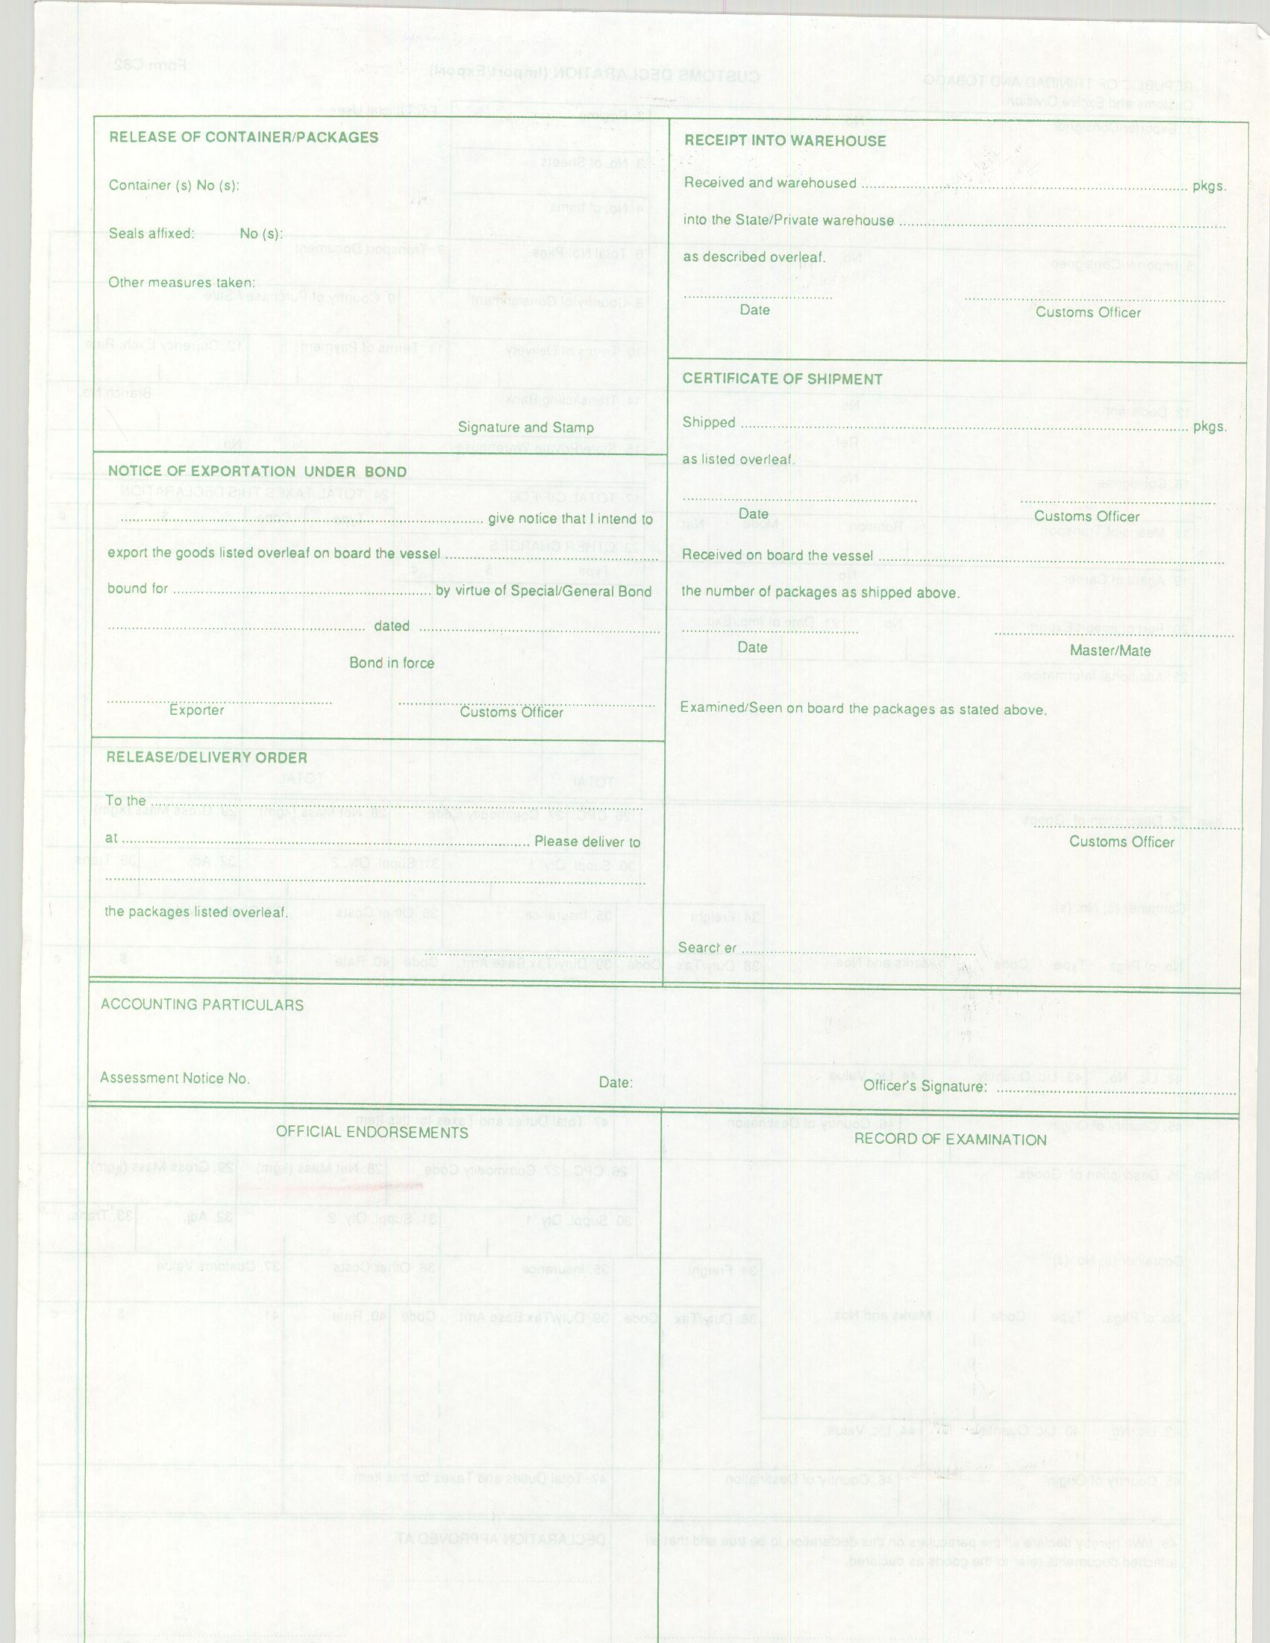

B. CARICOM INVOICE

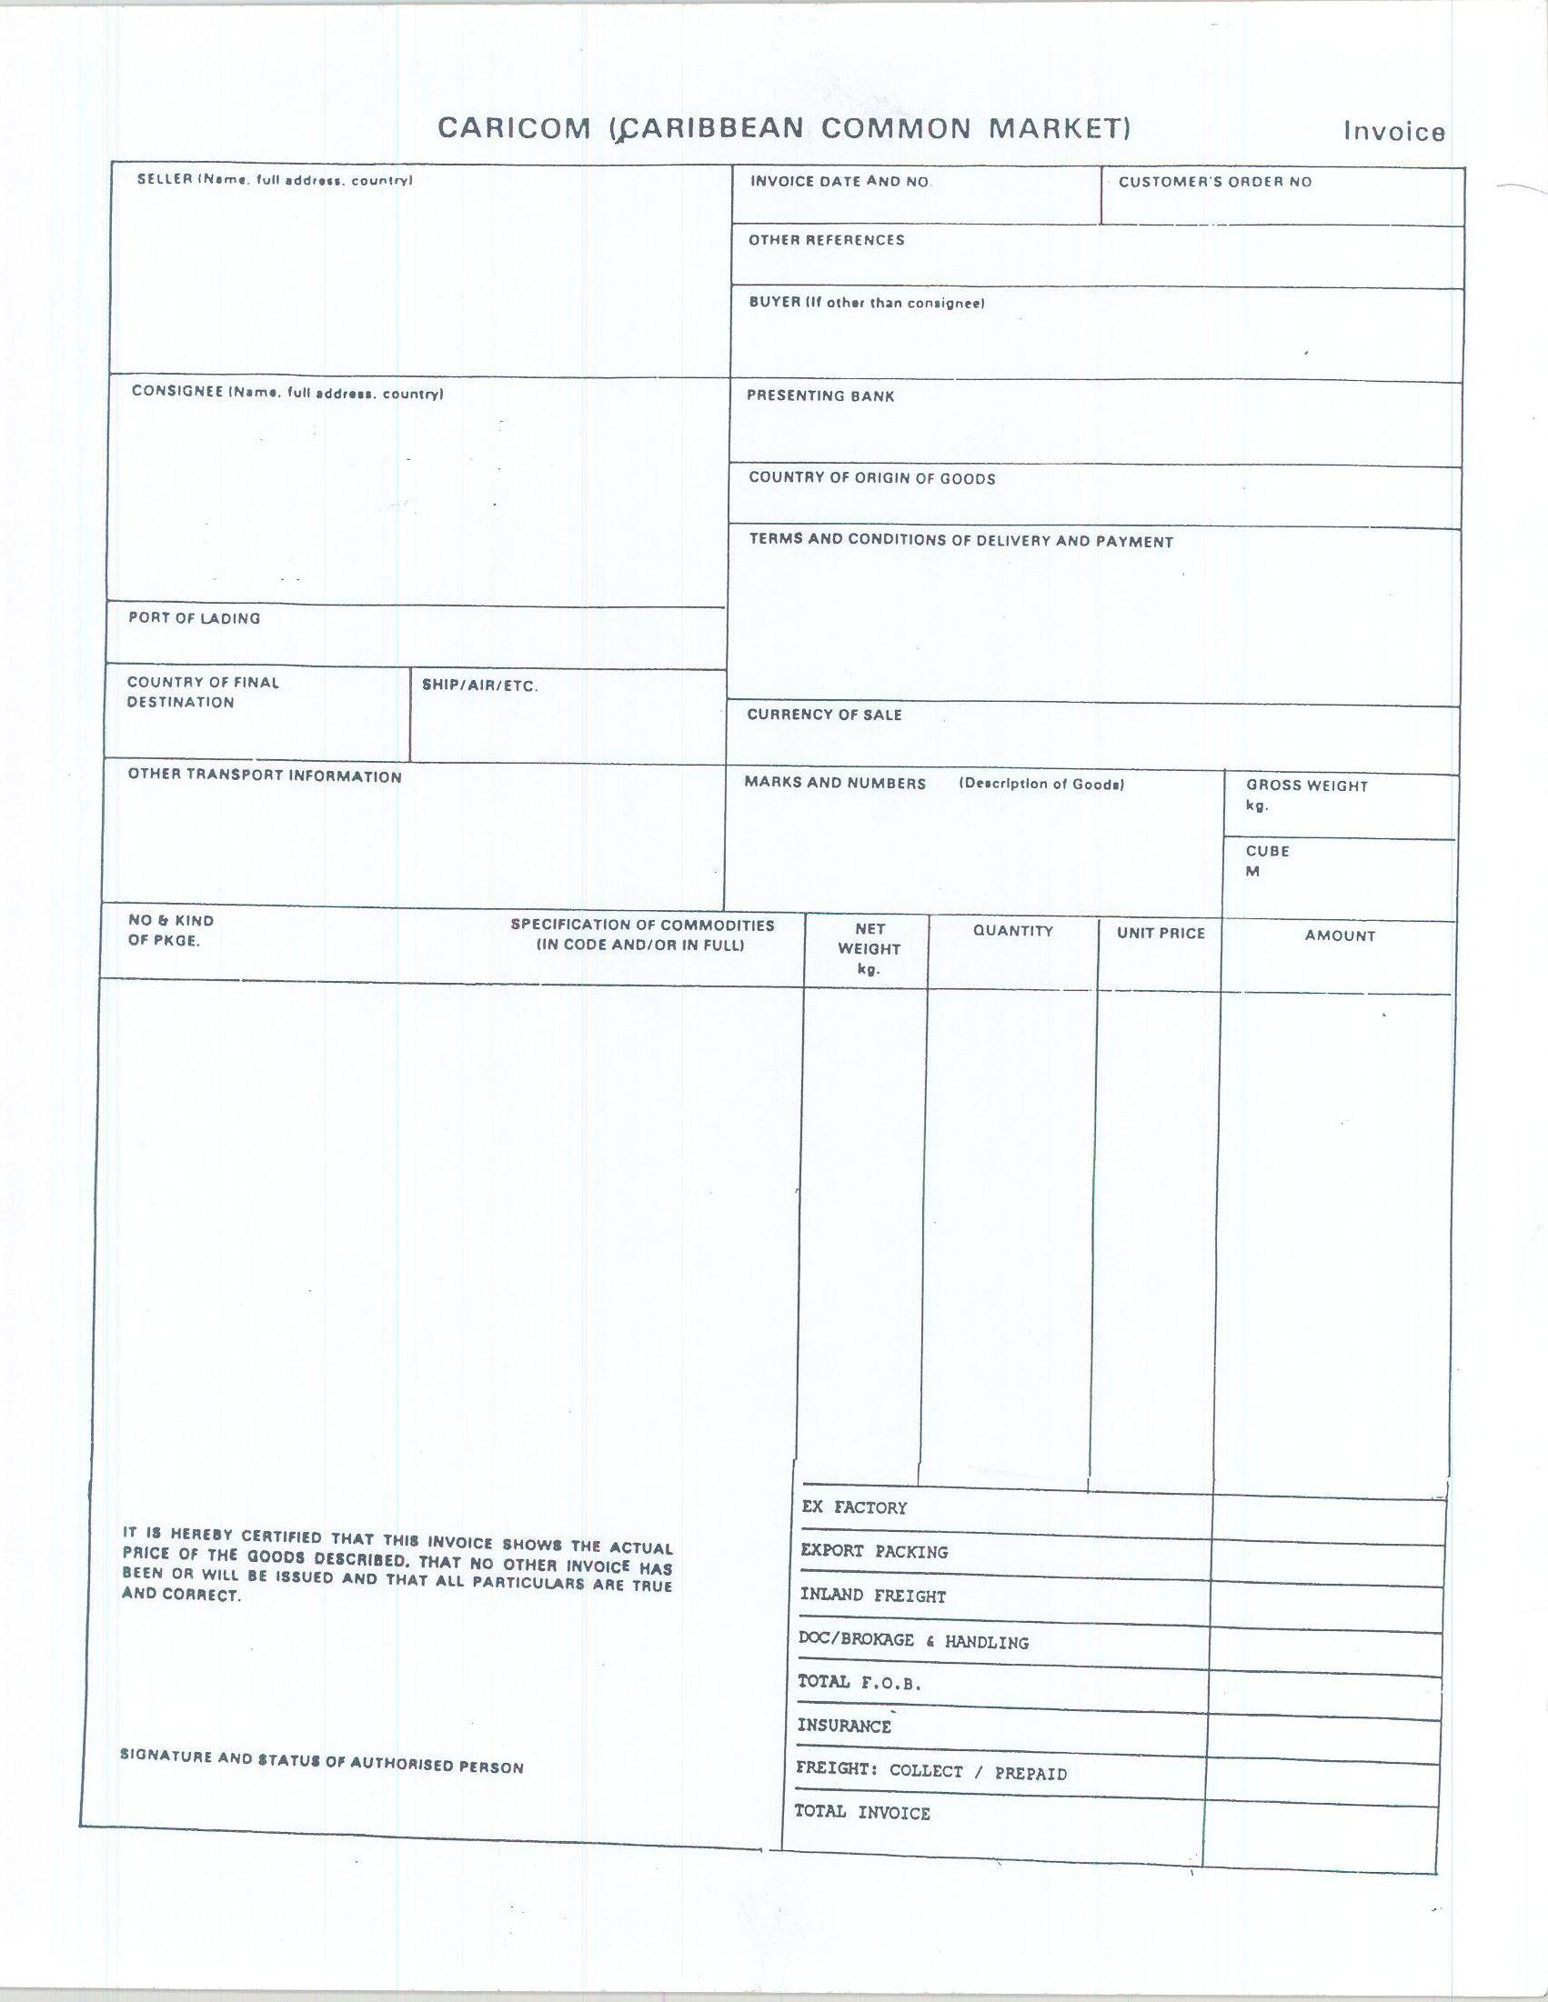

C. AIRWAY BILL

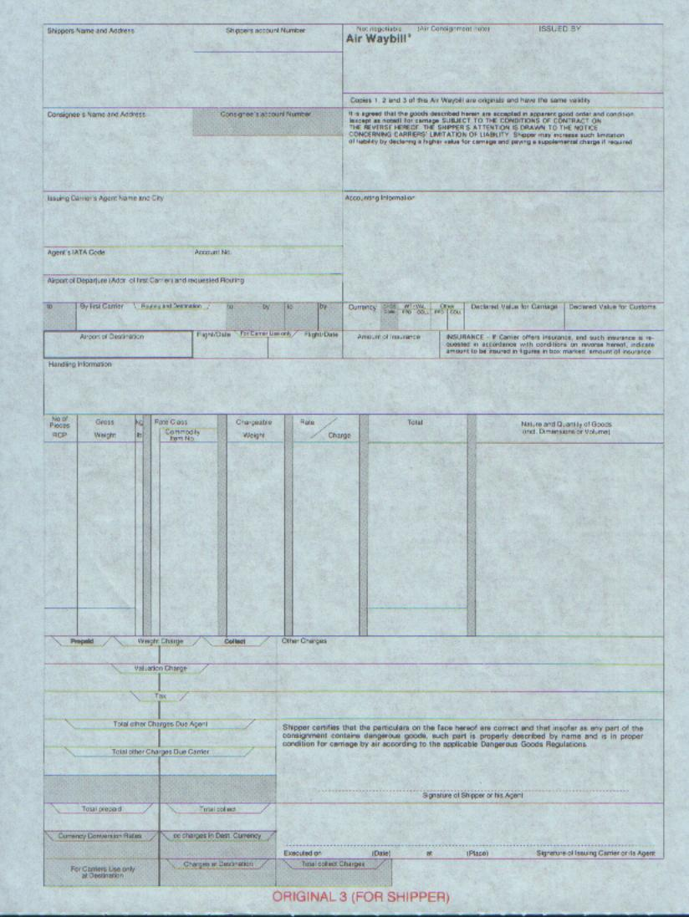

D. BILL OF LADING

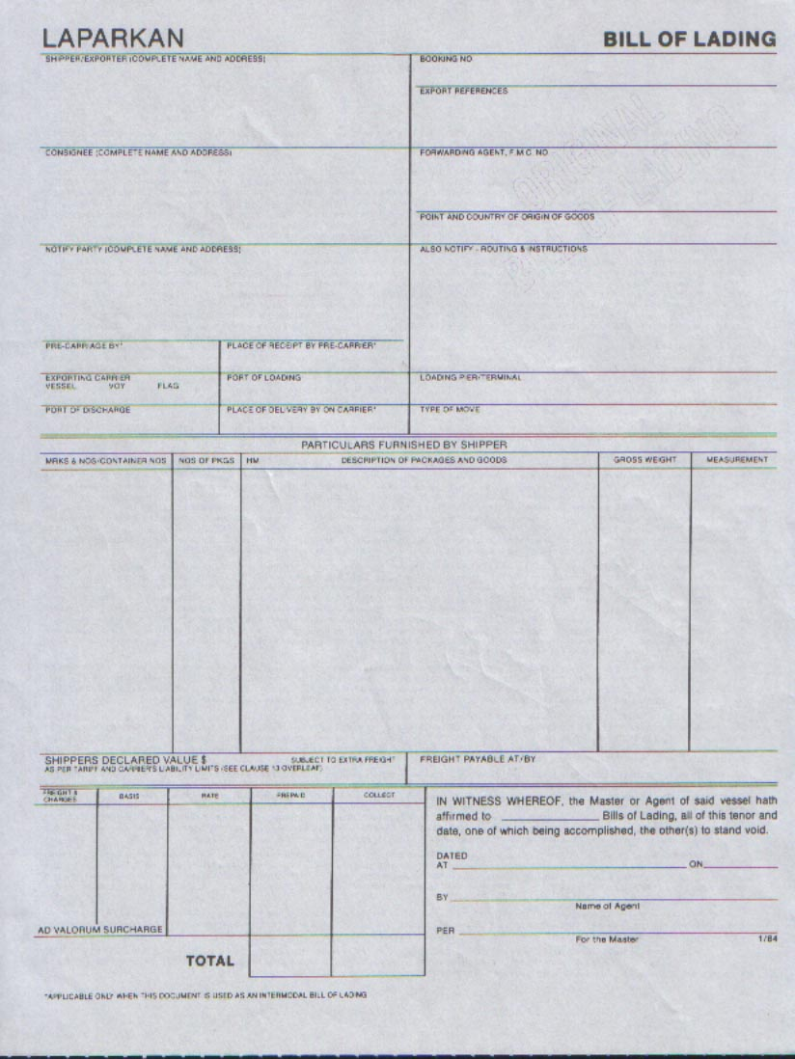

E. PHYTOSANITARY CERTIFICATE

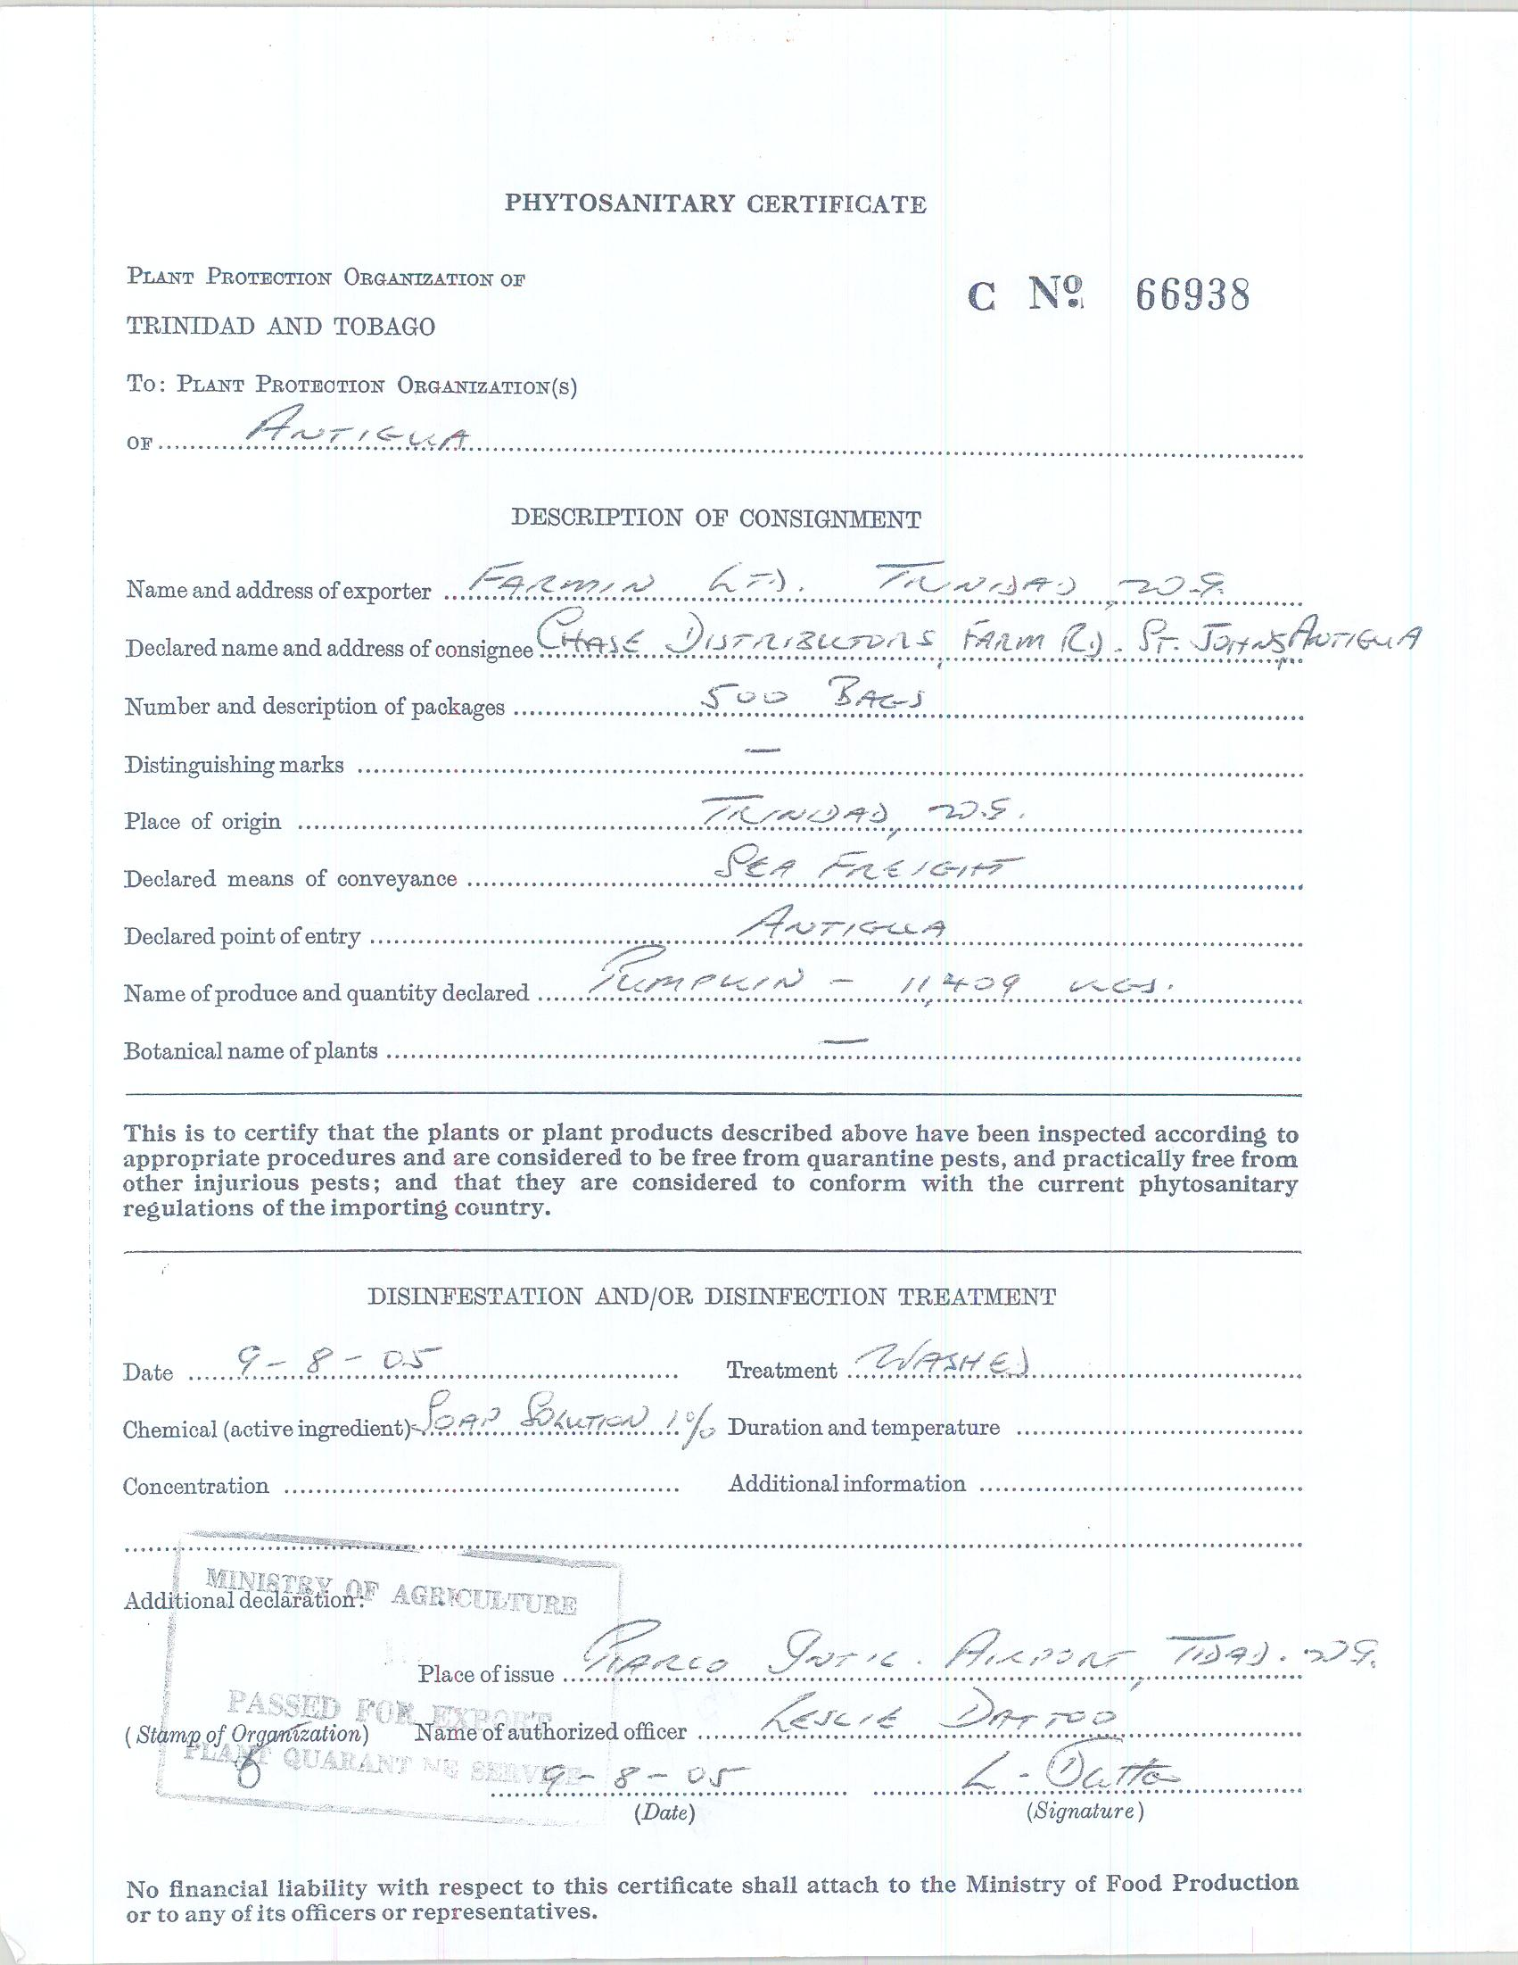

F. EUR 1 FORM (Front) – Certificate of Origin for Exports to the European Union
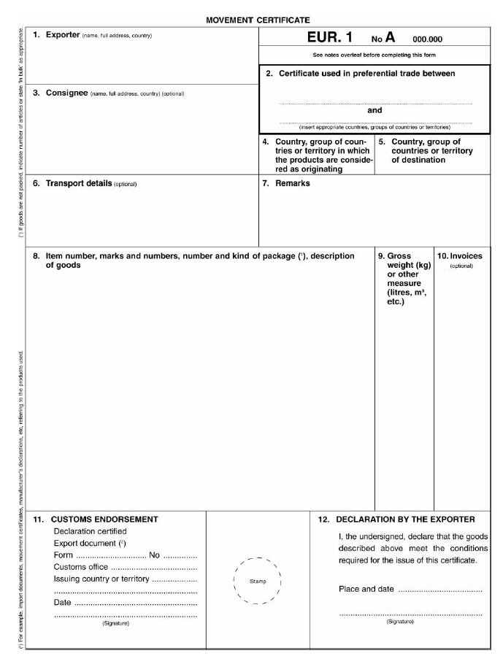

F. (Cont’d) EUR 1 FORM (Back)

