NATIONAL AGRICULTURAL MARKETING AND DEVELOPMENT CORPORATION
(NAMDEVCO)

Investment Profile
for

Pumpkin

Table of Contents

 |  | Page
1.0 | General Characteristics | 4
1.1 | Cultivars Selection | 4
1.2 | Production of Pumpkins Employing Good Agricultural Practices (GAP) | 4
1.2.1 | Site selection | 5
1.2.2 | Site Preparation and Soil | 5
1.2.3 | Nutrition | 7
1.2.4 | Irrigation | 8
1.2.5 | Weed Control | 9
1.2.5.2 | Chemical Control | 10
1.2.5.3 | Biological Control | 11
1.2.5.4 | Mechanical Control | 11
1.2.5.5 | Cultural Control | 11
1.2.6 | Crop Protection | 11
1.2.6.1 | Pesticide Applications | 12
1.2.6.2 | Field Scouting for Pest and Disease Development | 13
1.2.7 | Diseases | 13
1.2.7.1 | Anthracnose-Colletotrichum lagenarium | 14
1.2.7.2 | Gummy stem blight (Mycosphaerella melonis) | 15
1.2.7.3 | Powdery Mildew | 16
1.2.7.4 | Bacterial wilt (Erwinia tracheiphila ) | 16
1.2.7.5 | Phytophthora root rot | 17
1.2.8 | Pests | 17
1.2.8.1 | Squash bug (Anasa tristis) | 17
1.2.8.2 | Squash Vine Borer (Melitia cucurbitae) | 18
1.2.8.3 | Aphids Green Peach Aphid (Myzus persicae) | 19
1.2.8.4 | Army worm | 20
1.2.8.5 | Cucumber Beetles | 20
1.3 | Viruses | 21
1.4 | Harvesting | 22
1.4.1 | Maturity index | 22
1.4.2 | Temporary Storage | 23
1.4.3 | Harvesting Operations | 23
1.4.4 | Yield | 24
1.5 | Post Harvest Handling Of Pumpkins | 24
1.5.1 | Handling | 24
1.5.2 | Containers | 24
1.5.3 | Field Pre-cooling | 25
1.5.4 | Pre-cooling at packing or storing facility: | 25
1.5.5 | Curing | 26
1.5.6 | Transportation | 27
1.5.7.1 | Packinghouse operations | 27
1.5.7.2 | Inspection | 27
1.5.7.3 | Washing and Sanitizing | 27-28
1.5.7.4 | Drying | 29
1.5.7.5 | Waxing | 29
1.5.8 | Grading | 30
1.5.9 | Sorting according to size | 31
1.5.10 | Packaging | 31
1.5.11 | Labeling | 31
1.5.12 | Storage | 31
1.5.13 | Chilling Injuries | 32
1.5.13.1 | Freezing Injuries | 32
1.5.13.2 | Ethylene Production | 32
1.6 | Cost of Production Model for Pumpkin | 34-36
1.7 | Additional Information / Research Needs | 36
1.7.1 | Varieties | 36
1.7.2 | Commodity Chain | 36
1.7.3 | Market Analysis | 36
1.8 | References | 37

PUMPKIN PRODUCTION
- General Characteristics

Family: Cucurbitaceae
Genus and species: Cucurbita maxima

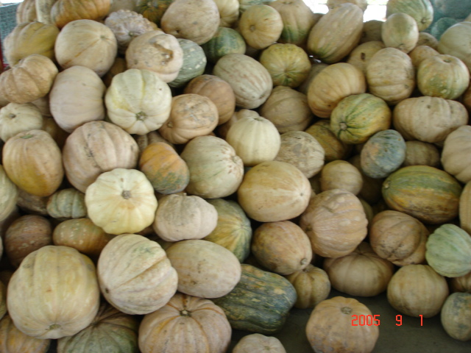

Pumpkins are a member of the Cucurbitaceae family, which also includes squash, cantaloupes, cucumbers, watermelons, and gourds.

Many farmers see pumpkins as a profitable opportunity. Because of this, the acreage under pumpkin cultivation has expanded greatly in recent years and competition in the pumpkin market is increasing.

  - Cultivars Selection

Varieties should be selected that show resistance to pest and diseases. This will greatly assist in the reduction of pesticide applications, while bearing in mind the market preference.

Some of the more popular varieties include Sweet Mama, Jamaican Belly or Jamaican yellow squash, and Black Diamond types, which are grown for the export markets and the Crapaud Back type, which are grown mainly for local consumption.

1.2 Production of Pumpkins Employing Good Agricultural Practices (GAP)

This crop profile describes the principles of GAP for the production of pumpkins as a safe food, environmental concerns and the general health of farm workers. These principles are applicable for all crops being cultivated for human consumption and will assist farmers, exporters and extension officers to manage the risks associated with food safety, health and safety hazards involved in crop production. In this brochure, attention is given to the specific areas of the production process where food safety hazards and risks may occur and putting in place the suitable controls for reducing the risks.

Areas to be considered:

- Site selection
- Site preparation
- Variety Selection
- Planting
- Nutrition
- Irrigation
- Pest Control
- Disease Control
- Weed control
- Harvesting
- Transportation
- Storage

    - Site selection:

The history of the prior usage of the ground is important because of potential hazards. The ground can be a source of contamination by microbial pathogens and harmful chemicals during production particularly if the land has been used for activities other than agriculture.

Information regarding the prior use of the land for grazing animal or animal production is important and can assist in identifying the risk of contamination with microbial pathogens found in the intestinal tract of animals.

If the area is prone to flooding it should also be avoided. Heavy flooding can increase the source of contamination by introducing contaminants from other areas.

1.2.2 Site Preparation and Soil

Pumpkins can be grown on most soil types, providing these are well drained and are of good fertility. Pumpkins are heavy feeders and thrive on large amounts of organic or pen manure. Mix compost or well-rotted manure into the bed to ensure an adequate supply of nutrients. Pumpkins grow best in soil with a pH between 5.5 and 6.5.

The soil should be well prepared to provide good tillage to approximately 30 cm deep and to assist in root penetration. If available, well- rotted pen manure should be incorporated in the soil during ploughing and rotovation operations. When there is the risk of water logging, especially in low-lying areas, plants should be planted on raised beds so that excess water can be removed from the root zone.

On soils with a high clay content, there is a greater risk of more problems with root and stem diseases because of the wetter soil surface and higher humidity in the lower canopy especially in the rainy season. In this instance there is often a benefit from planting on raised beds. Managing the crop on heavier soils is often aggravated by excessive moisture. In heavy clays, land preparation operations such as ploughing and rotovation help to improve the soil structure and so assist in drainage.

In low-lying areas in particular, where the drainage is poor, cambered beds are recommended

    - Planting and Spacing

Some farmers prefer to sow seeds in speedling trays or cups, others prefer to direct sow. This will of course depend on the size of the operation and pest and disease problems associated with the planting site. Sowing in cups has the following advantages:

- Facilitates proper root and plant development
- Better control of pest and diseases at the seedling stage

Pumpkins should be given sufficient room for the development of the maximum fruit per unit area while simultaneously allowing for easy access for harvesting. There appears to be a relationship between plant density and yield. Closer planting also reduces weed growth. However ample room is needed to vine spread and growth.

Sow 2-3 seeds, 1 inch (2.54cm) deep every 30-40 inches (76cm-102cm) and in rows 6-8 feet (1.8m – 2.4m) apart. Thin to one or two pumpkin plants.

Pumpkins can be grown in a “hill” of soil, compost or manure. Alternately sow 4-5 seeds per hill. Pumpkin hills should be approximately 3 feet by 3 feet. (0.9 x 0.9m). Allow 5 to 6 feet (1.5 -1.8m) between hills, spaced in rows 10 – 15 feet (3m X 4.6) apart. Seedlings should be watered daily. When the young plants are well established, thin each hill to the best two or three plants. The seed rate is 3-4 lbs (1.36-1.81 kg) per acre. (0.4 ha)

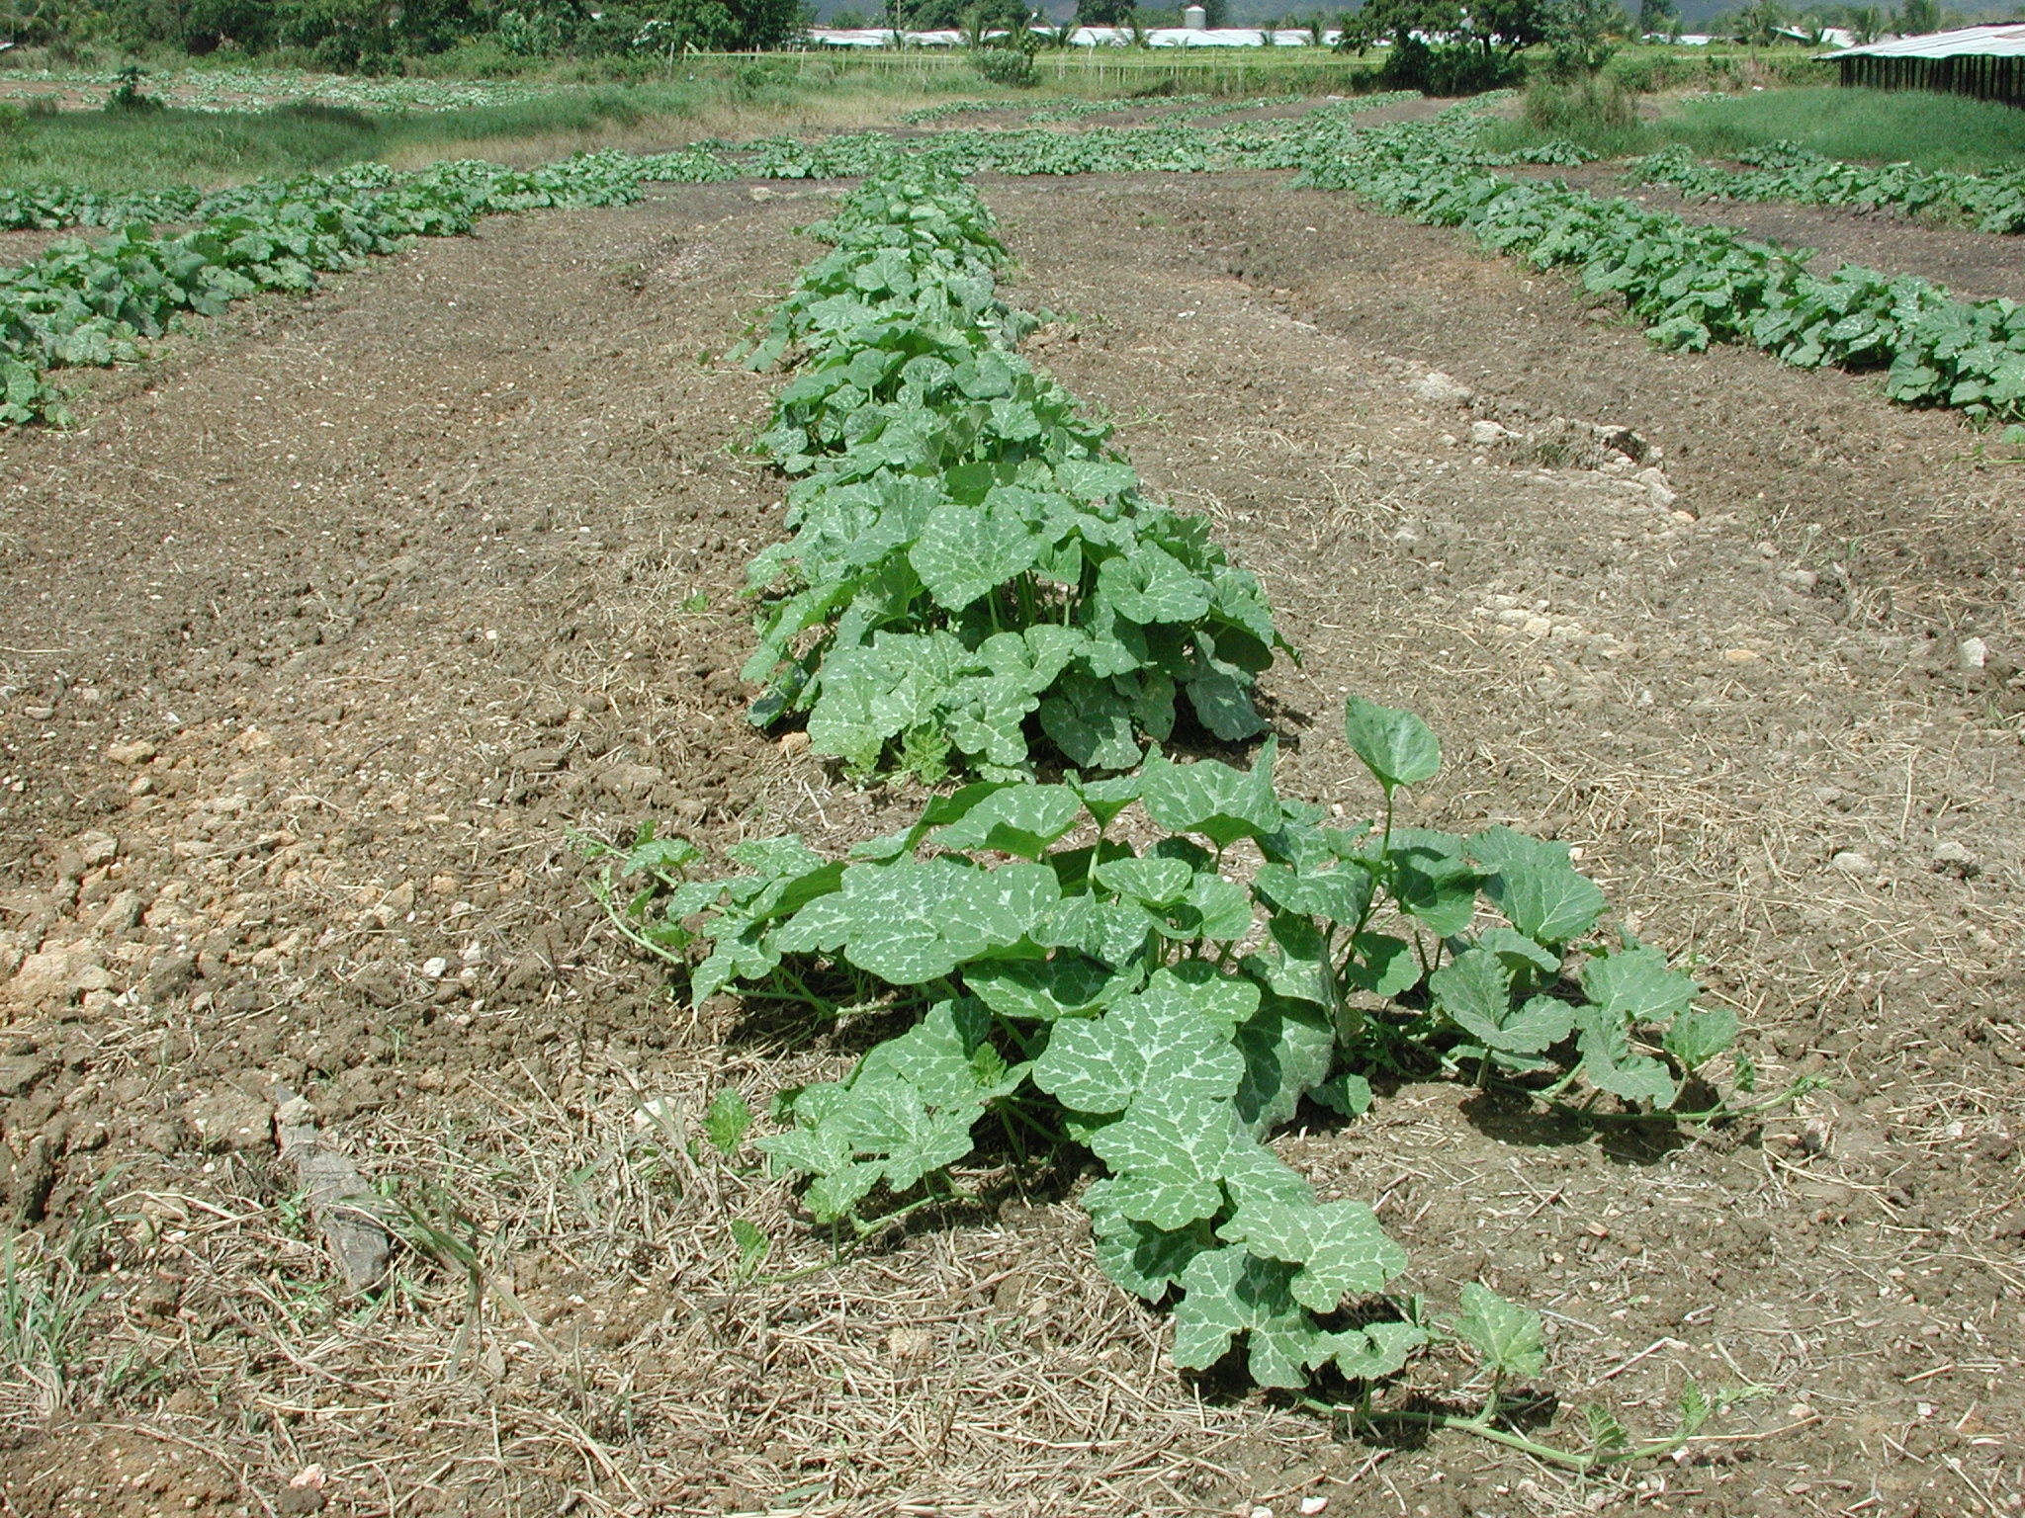

Single row cultivation of pumpkins

    - Nutrition

Fertilizer rates should be based on the results of a soil test and the nutrient requirements of the pumpkin crop. Excessive application of fertilizers can be wasteful and expensive and can also make it easier for the plant to give way to pest and diseases.
Also excessive use of inorganic fertilizers such as nitrates and fertilizers can find themselves into drains, rivers and ponds through ground water or surface runoff.

When using organic or pen manure:

- Personnel handling manure and compost should be vaccinated against tetanus and should not handle organic matter with open cuts/wounds. Proper precautions should be taken.
- Proper washing after handling raw manure and compost is also a very important practice in order to prevent illness of field operators

When using organic fertilizers other precautions that need to be taken include:

- Organic fertilizers must be properly treated prior to application
- It should be applied to the planting hole and incorporated in the soil prior to planting
- Organic fertilizers should not be applied when the crop is nearing maturity
- Maximum time should be allowed between application of organic fertilizers and harvest of the product
- Never use untreated manure directly to the plant crop.

Pumpkins need moderate amounts of potassium and phosphorus and high amounts of nitrogen. Pumpkins are large consumers of all the major plant nutrients (nitrogen, phosphorus and potassium), as well as many minor nutrients like calcium and magnesium and other trace elements.

Pumpkins respond well to ample dressings of organic manure, and artificial fertilizers may be applied at a rate of 600 – 800 pounds (272-363kg) per acre (0.4 ha) of a 5:10:10 NPK mixture.

- During the growing season, most fertility needs of pumpkins can be met by applying water-soluble plant foods once or twice a week over the entire plant area.
- Give seedlings a fertilizer that stresses phosphorus, such as 15-30-15. Shift to a more balanced formula, such as 20-20-20, once fruits are set.
- Once fruit set is evident, use a formula with a high potassium percentage, such as 15-11-29.

1.2.5 Irrigation

Water management is critical to the development of vigorous vines and the maintenance of the foliage canopy, which support fruit growth and protect developing fruit from sunburn. Pumpkins can be grown using sprinkler irrigation, but drip and furrow irrigation are also used. Trickle irrigation is best, but “soaker hoses” also work well. Overhead sprinklers are effective; however, wet foliage increases the chance of disease, especially mildew.

Frequent irrigation aggravates root and stem rot problems and increases humidity in the lower canopy, which contributes to foliage and fruit diseases. Irrigation management should emphasize infrequent, deep watering to encourage deep root development and allow time for the soil surface to dry between watering. When overhead irrigation is used, water should be applied early in the day so leaves can dry before nightfall to reduce the incidence of fruit-rotting and foliar diseases.

Water deficiency or stress, especially during the blossom-fruit set period, can reduce fruit size or cause blossoms and fruits to drop, resulting in reduced yields. Additionally, sandy soils require close attention to water management (more frequent irrigation) to avoid moisture stress and interruption in foliage or fruit growth.

The use of a potentiometer is a useful tool to determine moisture levels in the soil. In the absence of such equipment a simple way to determine the moisture level of the soil is to take a handful of soil and squeeze it. If the soil sample holds together and is sticky, the level of moisture is adequate; if the sample crumbles them moisture levels are inadequate and the filed must be irrigated.

Pumpkins require a good supply of water to produce large thick walled fruits. The source of water supply (ponds, drains, rivers etc) used for irrigation can be a potential source of biological and chemical hazards.

A recognized laboratory for microbial, chemical and mineral pollutants should analyze water used for irrigation at least once per year. Proper record keeping of microbial, chemical and mineral pollutants of the water is an important Good Agricultural Practice. Also water storage tanks should be kept covered to ensure that they do not become contaminated with bird faeces.

1.2.6 Weed Control
Pumpkins are not very competitive with weeds especially in the first few weeks of growth because they are planted in widely spaced rows, are short in stature, and require 8 to 10 weeks to close the canopy. The use of seedling transplants can assist in better control of weeds in the early stages.

As the vine senesces later in the crop, this will potentially open the crop canopy, which allows weeds to establish and produce seed.

Weed control can be achieved with herbicides and a good crop-rotation system. Several pre-plant and post-emergence herbicides are available for pumpkins, depending on the specific weed problem and pumpkin growth stage. If infestation levels are low, early cultivation (prior to vine running) can help minimize weed problems.
The five methods of weed control:
- Preventive
- Chemical
- Biological
- Mechanical
- Cultural
Any combination of these methods would constitute an Integrated Management Program.

1.2.6.1 Preventive Control
Preventive control is self-explanatory. It literally means to keep the weed or weeds from invading your land. Do this by inspecting your land for any unwanted or noxious weeds. Any plant that looks as if it should not be were it is may be a potential weed. Once a weed is found, eradicate it immediately. Do not let the weed have a chance to reproduce.

1.2.6.2 Chemical Control
Herbicides used properly by following the label and with common sense, are one of the main methods of control. Herbicides have several different modes of action. Before purchasing any herbicide, read the label to ensure that particular herbicide will do what you intend it to do. There are herbicides that will only affect broadleaf plants. Some will only affect grasses. These type herbicides are called selective. Some herbicides are non-selective, that is they will effect all vegetation or most of it. All this is found on the label.
One method of chemical weed control is the Stale Seedbed Method. This method requires tillage to prepare the seedbed for planting. This process breaks dormancy and triggers the emergence of early emerging weeds. Generally, the greatest proportion of the weed seed bank will emerge during the initial flush. After weeds have emerged they are destroyed with contact herbicides (e.g. glyphosate (Roundup®)), tillage, or burning. Tillage at this stage can result in an additional flush of weed emergence as soil mixing may break the dormancy of additional weed seed in the soil.
Glyphosate® provides broad-spectrum weed control and is a highly effective herbicide for managing many perennial weeds. Glyphosate is well suited for stale seedbed techniques.
Gramoxone® is an effective contact herbicide when using stale seedbed techniques. Gramoxone will damage all leaf tissue coming in contact with spray droplets, but will not translocate within the plant.
Selective herbicides such as Fusilade® can also be used to control of annual and perennial grass weeds in pumpkins.

1.2.6.3 Biological Control
Biological control is the use of living agents as a method of control. These agents can be; insects, bacteria or fungi. Some of these agents are very successful, while others are not so good. Most of these agents are limited to certain site criteria before they are effective. Inspect your land or site to make sure that the criteria is met before using any of these agents.

1.2.6.4 Mechanical Control
Mechanical control is the use of machinery, or any form of manual exertion (work) to control weeds. This includes the use of mowers, ploughs, chopping, etc. Mechanical control is very sensitive to timing to be effective. Mowing, ploughing or chopping needs to be done at the plants correct stage of growth. A common example is to plant the crop in the middle of the cambered bed and then plough in the weeds on either side of the planting hole. Most mechanical controls need to be done several times during the growing season.

1.2.6.5 Cultural Control
Cultural control is probably the most sensible control method available. It simply means to change something to make it harder for the weeds to grow or become established. Grazing, crop rotation, reseeding, and fertilization are all cultural practices that can enhance weed control.

1.2.7 Crop Protection

Crop protection from insect pest weeds, disease and weeds should be achieved with minimal reliance of pesticides. Integrated Pest management (IPM) programmes combine chemical, cultural, and biological practices into one programme to control pest populations. Cultural control usually starts before crop establishment.

1.2.7.1 Pesticide Applications

Insecticide applications should be made only when necessary. For control of diseases, fungicides are most effective when applied before disease begins to increase. The potential for very rapid increase is greatest shortly before harvest when the canopy is most dense or anytime during prolonged periods of rainfall. For example, effective squash bug control is dependent upon sufficient penetration of the leaf canopy by the insecticides to contact and kill the bugs. Insecticides and fungicides should be selected based on proven effectiveness.

Pesticide applications are timed and combined with other pest management practices to reduce the need for frequent applications.

Minimizing the amount of pesticide used reduces the cost and helps protect the environment. The pH of the water used affects how effectively the pesticide works. Some pesticides begin to break down as soon as they are combined with alkaline water in the tank, especially when the pH of the water is very high. As a consequence, the active ingredients start to change to inactive ingredients before the pesticide ever leaves the tank! The degree of pest control may be somewhat to greatly decreased or even lost completely. If a spray tank is allowed to stand for several hours or overnight before the contents are used, as much as 50 percent of the active ingredient may be lost.

Agricultural chemicals may be applied using a spay can or a mist blower. Some advantages of using a mist blower include:
- Uniform distribution of the chemicals throughout the crop foliage.
- Droplet size is much smaller, good coverage can be achieved with fewer chemicals.
- Reduces the potential for groundwater contamination.
Proper selection, calibration and operation of spray equipment is important in achieving optimal pest control, as well as in meeting environment and safety requirements.

Pesticides can be extremely dangerous to human and animal health if they are not handled properly. They represent a chemical hazard for workers in the fields for persons exposed to them as well as for consumers of fruit, vegetables and root crops contaminated by inappropriate treatments. All pesticides applications should be recorded on a pesticide record sheet.

A pesticide record sheet should contain information on:

- Crop data (Variety, planting date)
- Name of pesticide used
- Place of application
- Dosage
- Application dates
- Period of time before harvest
- Name of person responsible for application

1.2.7.2 Field Scouting for Pest and Disease Development

Fields should be scouted at minimum once per week after planting by walking across the entire field and can be a useful guide in making decisions regarding pest control.

If known, scout for diseases in areas of a field in which diseases tend to appear first.

Some keys areas to look comprise:

- Flower- flower drop an d the presence of insects
- Fruit- physical presence, damage due to scarring or the presence of insect ‘frass’ or droppings
- Area of stem above root zone- -fungal infections

Some foliar diseases will appear where air circulation is reduced and leaves remain wet, such as in low areas and along borders sheltered by trees. Foliar diseases typically appear first on crown leaves close to the base of the main stem. Root diseases tend to appear where soil remains wettest, such as in low areas and in heavier soils.

1.2.8 Diseases

Disease control is essential in the production of high quality pumpkin. A preventive program that combines the use of cultural practices, genetic resistance, and chemical control as needed, usually provides the best results.

Cultural practices are useful for limiting the establishment, spread, and survival of pathogen that cause pumpkin diseases. Many of the fungal, bacterial, and nematode pathogens survive in old crop debris and in soil; therefore it is recommended that fields should be rotated with non-cucurbit crops for at least three years to reduce pathogen levels.

Avoid acid soils or fields with a history of Phytophthora rot or root rots/ vine declines. The selection of well drained soils is essential for minimizing fruit rots.

Avoid the movement of contaminated soil or plant debris into clean fields on workers or farm equipment. Seeds can carry diseases such as angular leaf spot. This can lead to the introduction of disease into fields. Purchase seed from reputable sources as far as possible and apply a fungicide seed treatment prior to planting. Most foliar diseases are spread by water-splash or favored by long periods of leaf dampness.

Utilize drip irrigation or avoid frequent sprinkler irrigation with small amounts of water. Finally, use tillage practices that promote the rapid decomposition of old vines and fruit soon after harvest.

Management of foliar diseases such as powdery mildew may require fungicide sprays. Fields should be monitored at least weekly for early disease detection. Spray programs should be initiated shortly after the first appearance of disease, or beginning at flowering to prevent disease. A 14-day schedule has been effective in most instances, although a 7-day schedule may be required where powdery mildew is severe. Management of bacterial wilt may require the use of insecticide to control cucumber beetles, which spread the disease.

Some of the more common diseases affecting pumpkin production include:
Anthracnose, Gummy stem blight, Powdery Mildew, Bacterial wilt, Phytophthora root rot and Downy mildew.

      - Anthracnose-Colletotrichum lagenarium

Symptoms

As the pathogen invades the foliage, small, yellow, water-soaked spots develop. These affected areas enlarge, turn brown and shatter, or occasionally the entire leaf dies.

Rounded sunken spots appear on the fruit with a pinkish brown centre that later darkens. Usually these sunken spots do not penetrate deep into the fruit, but damaged areas provide an entrance for soft rot organisms. Other symptoms include elongated tan spots in the stem.

Disease Cycle
The pathogen can survive in infected plant debris and in and on the seed. As spores are produced on infected foliage and fruit, they are easily disseminated to other plants by rain splash and by various pieces of equipment used in production. The disease is favored by warm, moist environmental conditions.

Control
It is important to plant disease-free seed, practice crop rotation with unrelated crops, and plant on well-drained soils. Fungicides should be applied regularly as plants begin to vine. Several applications may be necessary to control the disease.

      - Gummy stem blight (Mycosphaerella melonis)

This disease can cause serious problems on stems, leaves, and fruit of pumpkins. This fungal disease is often first noted as a developing rot in the lower vine stem area but also may affect foliage. The infection can cause the fruit to soften or discolor or the stems of the fruit may shrivel, reducing the value of the fruit. Fruit may appear normal at harvest but may collapse in the stem scar area after shipment or sale.
Control
Apply Bravo®(chlorothalonil) 2 to 3 pts(1-1.4 litre) per acre(0.4 ha) for flowables or 1.5 to 2.5 lbs(0.7 -1.1kg) per acre(0.4 ha) for dry formulations (WP, DF, DG). Begin applications when plants are in first true leaf stage or when conditions are favorable for disease development. Repeat at 7-day intervals or sooner under severe disease conditions.
Apply Maneb® (maneb) 80 WP at 2 to 3 lbs(0.9-1.4kg) per acre(0.4 ha) for dry formulations (WP, DF, DG) or at 2 to 3 pts (1-1.4 litre) per acre(0.4 ha) for flowables.

      - Powdery Mildew

Powdery mildew (Erysiphe cichoracearum) is common in pumpkin fields throughout the cropping cycle and more severe in the dry season.

It is easily recognizable as a white powdery growth on upper and lower leaf surfaces. If not controlled, the disease completely destroys the foliage, and any fruit that survives will be sunburned and discolored. The loss of productive vines also severely restricts fruit yield and size. Fields should be frequently and carefully scouted and fungicides applied at the first sign of the disease.

      - Bacterial wilt (Erwinia tracheiphila )

Cucumber beetles infected by the bacteria, feed on the leaves of the pumpkin plant and acts as vectors of the disease.
Wilt is caused as a result of slimy ooze, which plugs the entire water-conducting tissue of the plant. The wilted plant will not recover, even if water is adequate in the soil.

The leaves of infected plant often appear chlorotic. This chlorosis, followed by death of the leaf tissue, usually starts at the margins of the leaves and progresses inward. Plants can be killed by bacterial wilt if infected when young or if large numbers of infective beetles are present.

Symptoms

Cutting a severely wilted stem at the base of a lateral branch or just above ground level and squeezing the cut end may distinguish bacterial wilt. Ooze will exude from the water-conducting tissue. By touching the ooze with your finger then slowly drawing your finger away, the milky, sticky ooze will string out into fine strands up to one-fourth inch long. A positive test is a strong diagnostic character, but a negative test does not mean that the plants do not have the disease. Another test is to place a freshly cut stem from a wilted part of the plant in a glass of water. If bacterial wilt is present, a milky exudate will appear at the cut ends. Both of these tests require patience, as the bacteria are in a sticky material and may not readily ooze from the cut stem.

Control
The most effective disease control is prompt elimination of cucumber beetles. The beetles can transmit squash mosaic virus as well as bacterial wilt and can cause severe damage by feeding on the leaves. Control should begin either when the first beetle is sighted or when the first cucurbit seedlings emerge. Remove or destroy any infected vines. Wilted plants cannot be saved.

1.2.8.5 Phytophthora root rot

Phytophthora root rot (Phytophthora capsici ) is a serious fungal disease of pumpkins where the soil remains wet for extended periods. Phytophthora may cause root rot, stem lesions, or foliar blight. Fruit may also be severely infested and rot. Warm temperatures and poor drainage favour development of this disease. Phytophthora can move rapidly, and disease incidence may be higher in fields planted after tomatoes or peppers.

1.2.9 Pests
The most common insect problems of pumpkins include cucumber beetles, squash bugs and squash vine borers. Control of squash bugs and vine borers should start when pumpkin vines begin to run and should continue on a regular basis.
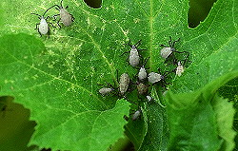

Squash Bug (Anasa tristis)

1.2.9.1 Squash bug (Anasa tristis)
Squash bugs damage plants by removing sap, causing leaves to wilt and collapse. Young plants and infested leaves on older plants may be killed.
Control
Cultural: After harvest is complete, deep tillage or removal of crop residue will help to delay and/or reduce infestation the next cropping cycle.
Chemical: Timing is the key to successful squash bug control. Insecticide sprays should target adults and small nymphs when the plants are small. It is much more difficult to control large numbers of older nymphs and adults when the plant canopy is dense. Treat with a recommended insecticide if adults are causing seedlings to wilt.
Squash bugs may begin to appear in pumpkin fields about the same time vines begin to run. Monitor for squash bug egg masses from pre-bloom through early flowering. Treat when egg mass numbers exceed an average of one per plant. It is advisable to apply insecticides to control the nymphs when they are young.

1.2.9.2 Squash Vine Borer (Melitia cucurbitae)

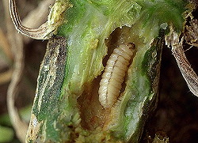

Squash Vine Borer (Melitia cucurbitae)

Symptoms appear when a long runner or an entire plant wilts suddenly. Infested vines usually die beyond the point of attack. Sawdust-like frass or droppings near the base of the plant are the best evidence of squash vine borer activity. If the stem is split open, one to several borers usually is present.
Controls
Cultural: After harvest is complete, deep tillage or removal of crop residue will help to delay and/or reduce infestation the next cropping season.
Chemical
The key to squash vine borer management is controlling the borers before they enter the stem. Therefore, they must be controlled on a preventive basis; once inside the vine, insecticidal control is ineffective. Poor timing of sprays is the usual cause of inadequate control. Monitor plants weekly for initial signs of the borer’s frass or droppings at entrance holes in the stems. Use two to three insecticide applications 7 days apart to control newly hatching larvae and continue to monitor for additional activity. A second approach is to initiate a weekly application of an insecticide starting when vines begin to run. Sprays need to penetrate the canopy to cover the vines to be effective.

      - Aphids Green Peach Aphid (Myzus persicae)

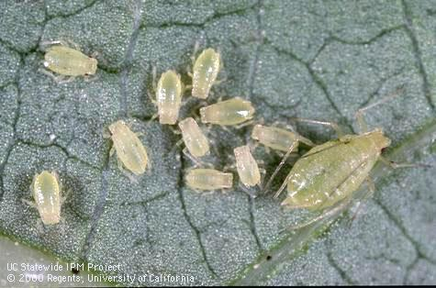

Aphids can move into pumpkin fields in large numbers from surrounding vegetation, carrying viruses as it moves and feeds from one plant to another. Aphids also cause problems by weakening the plant through feeding, and both whiteflies and aphids are also vectors of viral diseases.

Damage
Damage usually becomes obvious on cucurbits after the vines begin to run. Congregating on lower leaf surfaces and terminal buds, aphids pierce plants with their needle-like mouthparts and extract sap. When this occurs, leaves curl downward and puckers. Wilting and discoloration follow. Aphid damage weakens plants and may reduce fruit quality and quantity. Honeydew secreted by aphids makes plants sticky and enhances development of black sooty mold on plant foliage.

Control
Control weeds along drains, banks, roads, and other non-cultivated areas that contribute directly to the aphid problem.
It is important to treat early to insure that the aphids do not build up to high levels and treatment should be based on visual counts. Early treatment does not prevent virus introduction; treating, however, may help reduce spread of the virus if aphid colonies are present.

      - Army worm

Several species of armyworm (Spodoptera spp.) and looper (Trichoplusia spp.) larvae can also damage pumpkins. These larvae feed on foliage and occasionally damage fruit. They can be controlled with registered insecticides and biological controls such as Bacillus thuringiensis.

      - Cucumber Beetles

Cucumber Beetles (Acalymma vittatum, Diabrotica undecimpunctata)
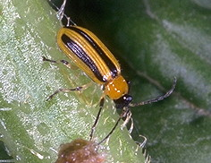

These beetles are vectors of bacterial wilt. Plants infected with the disease wilt quickly with leaves drying out prior to plant death. The causative bacteria, Erwinia tracheiphilia lives in the bodies of these beetles, which introduce the bacteria into the plants through the fecal contamination of feeding wounds. This is the only natural method of infection known. Beetles also spread squash mosaic virus.

DAMAGE:
Cucumber beetles are important pests of cucurbits. They cause four types of damage: seedling destruction, flower and foliage damage, root feeding, and transmission of bacterial wilt disease. The beetles feed on newly emerged cotyledons and stems, and they have been reported to go below ground level and feed on plants as they emerge. Adults lay eggs in the soil near the seedlings and larvae soon hatch and begin feeding on roots of the cucurbits. Larvae chew holes and tunnel into the roots. Damage by the larvae, except under dry conditions, is usually considered minor. Probably the most serious damage by cucumber beetles is from transmission of bacterial wilt. Bacterial wilt can kill many plants in a field and seriously reduce the yield. The striped cucumber beetle and the spotted cucumber beetle have very similar life cycles and both can carry the bacteria, but both are not equally important pests on cucurbits.
Control Practices:
Chemical control is often needed, particularly in commercial plantings. To prevent cucumber beetle damage to seedlings, treat when one beetle per 10 feet of row is found. To prevent bacterial wilt, treat when one beetle per 100 feet of row is found. Usually, a soil insecticide is used at planting time for control of cucumber beetles during the seedling stage and foliar treatments are applied as needed.

Insecticides
Application of an insecticide is usually recommended as soon as the plants begin to emerge through the soil. For prevention of bacterial wilt, it is often advisable to spray at 5-day intervals, beginning when seedlings emerge or after transplanting and continuing the schedule until vines run. If rain occurs within the 5-day period, repeat the treatment promptly and then return to the regular 5-day treatment interval.
Sprays prepared from wettable powders are less phytotoxic than sprays prepared from emulsifiable concentrates. Malathion® may cause injury to plants if applied before they start to vine. Malathion® may cause some foliar burning and should not be applied when plants are wet.

1.2.9.5 Viruses

Viruses cause some of the most serious diseases of pumpkins. Of the viruses affecting pumpkins are those of most importance are transmitted by aphids, whiteflies, leafhoppers, and beetles. Virus transmission is specific, however. Viruses such as cucumber mosaic virus (CMV), watermelon mosaic virus (WMV), and papaya ring spot virus (PRV) are transmitted by aphids in a non-persistent manner, requiring only seconds to a few minutes for the aphids to probe the leaf surface and transmit the virus.

If possible, other cucurbits should not be grown in the same area prior to planting pumpkins to avoid movement of virus from one crop to another. It is always desirable to plant succeeding crops of pumpkins or other cucurbits upwind of previously planted cucurbit crops. Other crops such as peppers may also harbor a number of viruses that can also affect neighboring cucurbit crops.

1.3 Harvesting

Before the crop is harvested, the grower must ensure that the harvest interval has passed for each chemical applied to the pumpkin crop. Spraying records must indicate a safe handling date for each application. Also certain considerations prior to harvesting must be taken into account such as:
- Personal hygiene of harvesters to minimize contamination
- The use of clean field crates and trailers for collection, transporting and temporary storing the harvested fruits
- Only harvest sound and mature fruit
- Do not harvest immature fruit, use clean knives etc

1.3.1 Maturity index

Pumpkins are ready for harvest at approximately 12-14 weeks after planting. Fruits are ready to harvest when:
- The tendrils start turning brown,
- Skin or rind becomes hard,
- Fruit becomes dense and heavy.
- The stem near the fruit turns yellow, surface sheen of fruit decreases
- And fruit sounds hollow when tapped.
A latex test at the stem can also be done, by making a small incision. Immature fruits are cream to light yellow, maturing fruits are light yellow and mature fruits have a yellow to orange internal colour. Do not use thumbnail test on pumpkins. Most farmers in Trinidad use this technique to determine maturity of the fruit; this should not be encouraged since the fruits become susceptible to pathogen invasion causing rots and decay.

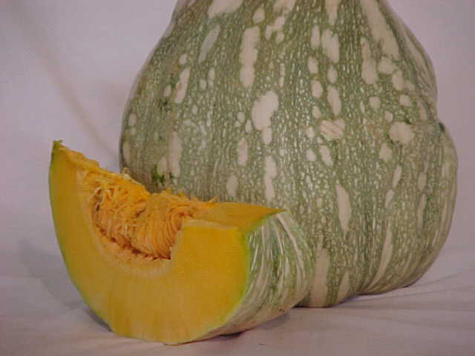
Mature pumpkin

1.3.2 Temporary Storage

Facilities used for temporary storing pumpkins should be:
- Designed for easy cleaning and sanitizing with sloping floors
- Well protected to prevent entry of vermins, animals, birds and insect
- Storage are should be kept free from residues and other waste materials that can introduce hazards into the facility.

An established cleaning and sanitization schedule is part of a GAP programme.

1.3.3 Harvesting Operations

Pumpkins are harvested by cutting the vine with a sharp knife or hand clipper. Cut stems flush to the shoulders of the fruit. Improperly trimmed stems or long stems encourage the potential for bruising and can act as portals of entry for pathogens. This ensures that fruit rot pathogens at the point of attachment does not occur. Do not lift the pumpkin fruit by the stem; this will detach the fruit from the stem. Harvest pumpkins under cool dry conditions. Do not handle wet fruits. Care must be taken at all times to prevent wounds on the surface of the fruit.

Harvested pumpkins along the field make it easy for trailers or trucks to drive through and load fruits. Where trailers are used they can be fitted with a roof to facilitate cooling of the fruits. All surface areas where fruits are placed should be lined with a cushioning material (e.g. multi-layered slippers ends) Polyethylene plastic sheet should be placed on field where pumpkins are harvested to prevent soil contamination and debris.

After fruits are harvested they are loaded into transport vans or stored in bulk bins until ready for transport.

1.3.4 YIELD

The average yield of pumpkin is between 20 to 30 tonnes/ha. In well-cultivated fields hence appropriate accommodation for transportation and storage should be made.

1.4 POST HARVEST HANDLING OF PUMPKINS

1.4.1 Handling

Pumpkins are handled in bulk. When harvested, they are loaded into bulk bins directly from the field or loaded directly to transport vehicles. Handle pumpkins from the bottom and carefully arrange the fruits in bins to protect the stem and other pumpkins from puncture wounds. Punctures and bruising will compromise the long-term storage quality of the fruit. Ideally pumpkins should be placed in a single layer where they do not touch each other for storage. This is not always practical as space is a limiting factor. In these instances where the fruits are stored for one to two days a layer of cushioning material can be used between layers. It is not advisable to store pumpkins more than 90 cm (3 ft) high. Good air circulation helps to prevent moisture from forming on the surfaces of the fruit and retards the growth of decay fungi and bacteria. Placing the pumpkins in piles generates unwanted heat, which may result in the rotting of some fruit.

1.4.2 Containers

Plastic crates: These are commonly used to harvest, transport and temporarily store pumpkins. They can hold approximately 365 kg (800 lbs). They are durable and easily cleaned and sanitized. These are preferable in harvesting and transporting pumpkins.

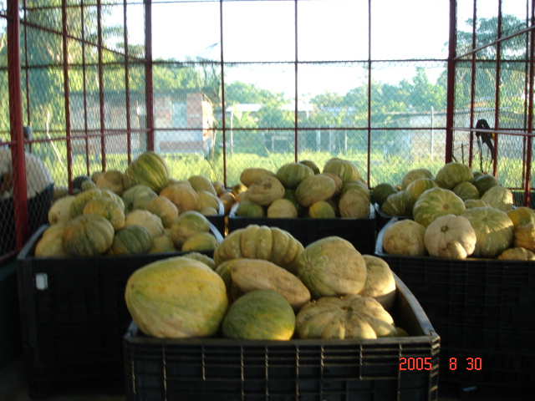 Pumpkins in ventilated crates

1.4.3 Field Pre-cooling

Typically trailers and pick-ups are used in the field to load produce after harvesting. It is recommended that these should be padded and an appropriate cover should be used to prevent direct scorching of the fruit from the sun’s rays.

After fruits are harvested they should be moved to a shaded area away from direct sunlight and high temperatures. The field shed should be situated away from direct sunlight. Polyethylene plastic spread on the floor to prevent contaminants from field to shed reduces deterioration.

1.4.4 Pre-cooling at packing or storing facility:

Pre-cooling for 4-6 hours after harvesting helps maintain quality of the fruit.
- Cold water dip:
Pumpkins placed in cold water at a temperature of 13 to 15 ⁰C removes field heat.
- Mist application
Fruits on arrival at the packing are passed through a heavy mist of cold water

Once water is used for pre-cooling, the fruits should be dried immediately as excess moisture can promote fungal infections.

1.4.5 Curing

The objective of curing is to prolong the storage life of the fruit by slowing the rate of respiration and protecting against storage rots. Fruits should be dry before entering storage.
Lowering the temperature most effectively controls respiration rate. For each 10 ⁰C reduction in fruit temperature, the respiration rate reduces by approximately one half. Curing promotes wound healing by producing corky tissues, hardening of the skin, heal surface cuts and ripening of immature fruits. Relative humidity (air moisture) has little effect on respiration, a relatively high level (70 to 75%) is needed to protect against excessive shriveling. Relative humidity greater than 85% can enhance disease development and shortens storage life.
Curing can be done in the field with protection from the sun by placing under leaves before handling and stacking into bins or wagons will help to harden the skin after harvesting. A shed situated away from the field, protected from rain and sunlight can store the pumpkins during curing. Temperatures not exceeding 30 ⁰C for 3-5 days promote curing of pumpkins.
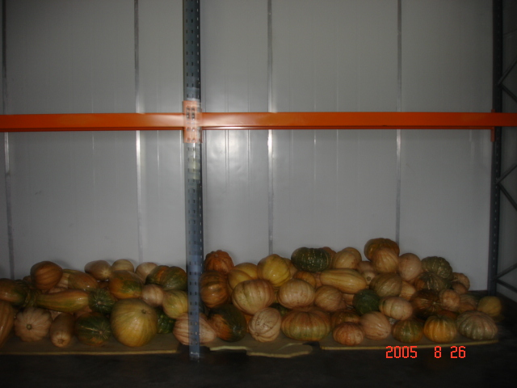

1.4.6 Transportation

Transport vehicles should be clean, padded at the bottom to prevent bruises and wounds while transporting. Pumpkin of the same size should be transported together to reduce friction and bruising of the fruits. It is recommended to pad between each layer.

Transport to the packinghouse should be done in the cooler parts of the day to prevent over heating. Loaded field vehicles should be parked in shaded area to prevent warming and sunburns. During transportation, fruits should be covered and taken directly to the packinghouse to reduce the risk of potential contamination that may occur between field and pack-house/ storage facility. Pumpkins are then transported to packinghouse.

Measures should be adopted to avoid cross contamination from other produce, non –food sources and contaminated surfaces during loading, unloading, storage and transportation operations.

1.4.7 Packinghouse operations

1.4.7.1 Inspection

All pumpkins received at the packinghouse are randomly inspected for:
  - Presence of insects and diseased fruits
  - Excessive dirt and foreign materials
  - Signs of pesticide residues
  - Bruising
  - Rots
  - Off-odours
  - Deformities
Produce handlers are advised to investigate all off odours as this can be a sign of deteriorating produce.

1.4.7.2 Washing and sanitizing

An automatic washing system can be implemented. This type of system ideally operates with uniform sized fruits. A simple system can be constructed by using a conveyor and nozzles above emitting water at a controlled rate. For the removal of debris and contaminants, pumpkins are washed and then rinsed with clean water. A light food grade soap solution can also be used to wash the pumpkins.

After the pumpkins are washed they should be dried and they either dipped in or wiped with a food grade sanitizer and allowed to air dry.

The solution should be changed regularly to ensure the required concentration and optimum efficacy. Simple devices such as a pH meter or chlorine meter can be used to ascertain the required levels.
Additional treatments as required by the consumer or buyer can be done at this stage such as the use of fungicide.

Washing pumpkins

Sanitizing pumpkins

1.4.7.3 Drying

Preference should be given to air-drying at ambient temperature. Care should be taken to ensure the stem area is properly dried to prevent rotting.

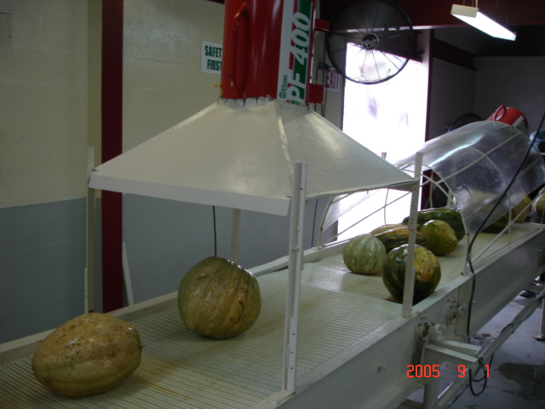
Drying pumpkins

1.4.7.4 Waxing

Waxing is an option to promote longer shelf life of the fruit. Waxing also enhances the appearance of the fruit as well as seal in moisture and protects fruits from pathogen entries.

1.4.8 Grading

In Trinidad, there are three proposed grades for pumpkins, Grade 1, Grade 2 and Grade 3.

Grade 1 pumpkins are free from damage; well-shaped, trimmed, uniform colour and not more than 5 % of the surface area have blemishes including ground spot.

Grade 2 pumpkins are free from damage, well shaped, fairly well trimmed, uniform colour, and not more than 10% of surface area have blemishes or ground spot.

Grade 3 pumpkins are free from serious damage, fairly well shaped, fairly well trimmed, fairly uniform colour and have no more than 20% of surface area blemish and ground spot.

Only grade 1 and 2 are exported from Trinidad and Tobago.

1.4.9 Sorting according to size

Size | Weight (kgs)
Giant | >25
Extra large | 15-25
Large | 10-15
Medium | 5-10
Small | <5
In Trinidad pumpkins are classified according to the sizes shown in the above table. Pumpkins are sorted according to colour. Uniform colour accounts for 90% of the surface colour and fairly uniform colour accounts for 85% of the surface colour. The stem should be attached to the fruit and trimmed at a length of 2.5cm. Fruits with cracks, scars, decay, rots or discoloration are discarded.

1.4.10 Packaging

At the packinghouse, fruits are packed in ventilated polypropylene bags weighing 50 lbs, an average of 2-3 fruits; mesh bags or double walled fiberboard boxes with dividers can also be used.

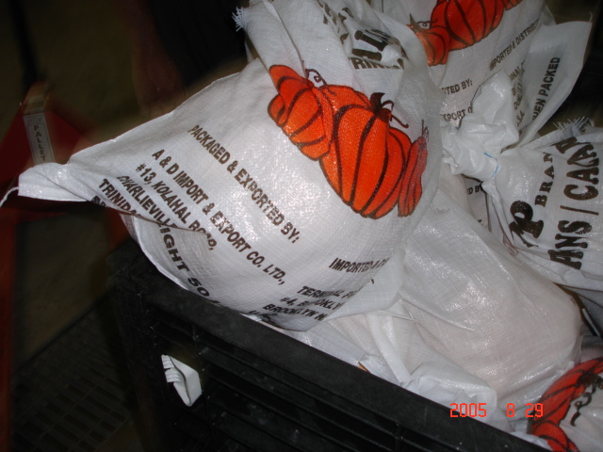

Packaged Pumpkins

1.4.11 Labeling

The packaged pumpkins are then labeled. Labels are placed in the bags with relevant information. Labels aids in proper identification of the fruit, exporter, grades and treatments on the produce.

Labels for export should contain the following:

- Name and address of the exporter/packer
- Common name of the commodity and varietal name
- Country of origin
- Net weight of the container /package in kilograms
- Number of pumpkins per container (optional)
- Trinidad and Tobago grade

1.4.12 Storage

Pumpkin can be stored for 2-6 months depending on the variety. Good quality pumpkins can be stored at room temperature for a few weeks. After packing, pumpkins are stored at 10-16⁰C at 60% relative humidity until transported for export or local markets. Storage at high temperature results in excessive loss of weight, color, and culinary qualities, while high humidity promotes rot.
Long storage periods, pumpkins should be placed in slatted shelves with good ventilation. Fruits must be stored in a dry place and turned at intervals during long-term storage to avoid compaction subsequent deterioration.

It is advisable to pre-cool packaged pumpkins before they are packed in the refrigerated containers for shipping.

1.4.13 Chilling Injuries

Pumpkins are highly sensitive to chilling injuries; they are prone to chilling injuries if stored below 9 ⁰C. Sunken pits on the surfaces and high levels of decay once fruits are removed from storage are seen as chilling injuries of pumpkins.

1.4.13.1 Freezing Injuries

Freezing injuries occur below -0.8⁰C for pumpkins.

1.4.13.2 Ethylene Production

Ethylene production can be increased 3-5 times higher if chilling occurs.

PROCESSING FLOW OF PACKINGHOUSE OPERATIONS

Off load from Trucks/Vans

↓
Inspect

↓
Weigh pumpkins

↓
Wash

↓
Sanitize

↓
Air dry (blowers)
/ Wipe with dry soft cloth

↓
Sort/Grade/Inspect

↓
Pack in 50lbs bags

↓
Store in chillers

↓
pack into refrigerated containers for export markets

1.5 Cost of Production Model for Pumpkin

NATIONAL AGRICULTURAL MARKETING AND DEVELOPMENT CORPORATION (NAMDEVCO)
COST OF PRODUCTION MODELS (TT$) August 2005
PUMPKIN
Variety: MIXED LOCAL
Wet Season
Location: Wallerfield (large farmer) Spacing: High density - 1,087 plants/ha Yield = 20,455 kg/ha
ACTIVITY | Unit | Quantity | $/Unit | Total ($) | Total Value ($) | Remarks
Land Preparation |  |  |  |  | 2,750.00
Brushcut | ha | 1 | 875.00 | 875.00
Plough | ha | 1 | 875.00 | 875.00
Rotavate | ha | 1 | 1,000.00 | 1,000.00
Transplanting |  |  |  |  | 135.00
Seedlings | trays | 9 | 15.00 | 135.00
Fertilising |  | 10 |  |  | 4,447.76
12:24:12 | bags | 3 | 120.00 | 300.00
12:12:17:2 | bags | 3 | 130.00 | 325.00
9:6:24 | bags | 5 | 130.00 | 650.00
Manure | bags | 750 | 2.00 | 1,500.00
Nutrex | 2.27kg | 8.01 | 30.00 | 240.29
Evergreen | litre | 3.00 | 100.00 | 300.00
Best-K | litre | 3.00 | 95.00 | 285.00
Newfol-Ca | litre | 9 | 95.50 | 847.47
Fungicides |  | 23.92 |  |  | 1,161.63
Pillastin | litre | 6.00 | 90.00 | 540.00
Daconex | kg | 8.87 | - | -
Novazeb | kg | 3.55 | - | -
Alliette | kg | 2.50 | 204.65 | 511.63
Rovral | 500ml | 3.00 | 36.67 | 110.00
Insecticides |  | 45.80 |  |  | 4,079.03
Factac | litre | 6.00 | 19.63 | 117.78
Karate | litre | 1.50 | 60.00 | 90.00
Tambo | litre | 2.25 | 125.00 | 281.25
Dipel | kg | 1.14 | 110.00 | 125.00 |  | At fruit set
Padan | 100grams | 22.50 | 22.00 | 495.00
Azadirect | 500ml | 9.00 | 330.00 | 2,970.00
Sevin | kg | 3 | - | -
Weedicides |  | 10 |  |  | 725.00
Swiper | 4.55litre | 5 | 95.00 | 475.00
Broadtril | 500ml | 5 | 50.00 | 250.00
Labour |  | 37 |  |  | 2,990.00
Land preparation | mandays | 2 | 60.00 | 120.00
Transplanting | mandays | 3 | 60.00 | 150.00
Fertilising | mandays | 5 | 80.00 | 360.00
Pest/Disease control | mandays | 18 | 80.00 | 1,440.00
Weed control | mandays | 1.5 | 80.00 | 120.00
Harvesting | mandays | 6 | 100.00 | 600.00
Loading vehicle in field | mandays | 2 | 100.00 | 200.00
Transportation |  |  |  |  | 193.00
Seedlings | crates | 9 | 2.00 | 18.00
Fertilisers | bags | 10 | 2.50 | 25.00
Manure | bags | 750 | 0.20 | 150.00
Miscellaneous: |  |  |  |  | 240.00
Refreshments | each | 12 | 20.00 | 240.00
TOTAL |  |  |  | 16,721.41 | 16,721.41 | per hectare
 |  |  |  |  | 6,688.56 | per acre
Summary
Plants/ha | 1089
Yield/ha (kg) | 20,455
Yield/plant (kg) | 18.78
Cost per ha | 16,721.41
Cost per kg | 0.82
Cost per lb | 0.37

1.6 Additional Information / Research Needs
For the document to be of further assistance as a guide to investing in pumpkin the following information will be useful.
1.6.1 Varieties: include description with photos of varieties available
1.6.2 Commodity Chain: describe the main producing and marketing channels for locally produced pumpkin
1.6.3 Market Analysis: Describe the historical production and marketing trends of pumpkin, which would include information on peak demand periods.

1.7 REFERENCES
http://anrcatalog.ucdavis.edu/pdf/7222.pdf

http://www.ext.vt.edu/pubs/plantdiseasefs/450-707/450-707.html- picture of downy mildew
http://www.ext.nodak.edu/extpubs/plantsci/hortcrop/pp747w.htm
http://pubs.cas.psu.edu/FreePubs/pdfs/ua293.pdf
Fig. 1. Brown, angular spots typical of downy mildew on the upper surface of pumpkin leaves.
(Photo by R.L. Wick-U. Mass.)
http://www.ext.vt.edu/departments/entomology/factsheets/cucbeet.html
http://www.wisconsinfreshproduce.org/_members/newsletter/weeds_pumpkins.htm

http://pestdata.ncsu.edu/cropprofiles/docs/KYpumpkin.html

Disclaimer
Commercial products are named in this publication for informational purposes only. NAMDEVCO does not endorse these products and does not intend discrimination against other products, which also may be suitable.

